FINAL REPORT OF ÖZGÜR PROJE
Determining Refugee Problems,Issues which caused by asylum of Countries, Comparative Analysis of Refugee Politics and Attitudes to Refugees of Chosen Countries (England, Italy and Turkey)
Project Coordinators
Beyza Ünsal
Mert Gürkan
May 2015-January 2016
ABSTRACT
In this project, project team aimed to define the notion of being a refugee, the attitudes of governments to refugees, to observe problems of refugees and the opportunities which are provided by countries that those people migrated. In order to do that, several methods and materials are determined.Firstly, project group made literature research about these topics which are listed above. Throughout the project, the news which are about refugees and immigration are covered. As field research, team members went the selected countries (England, Italy and Turkey), visitied immigration centers and met with the people who work on this field. Visiting different immigration centers in different countries provided sufficient information for comparing those countries in terms of their attitudes and their facilities to refugees. Finally, all information that are provided from different sources are evaluated by the team and this analysis report is prepared to show current situation to people.

INTRODUCTION
Being a refugee – one of the major problems of the world when causes and outcomes like civil wars, conflicts, starvation, dangerous migration paths and many others are considered. In this two sided chain of problems, one part is refugees forced to leave their homes and countries, their leaving process and their leaving paths, problems that they faced in different countries if they can reach. Other side of the problems are reactions and responses by governments to this flow of people which is rising in pace day by day.
Before going into details, there should be a clarification to definition of two terms confused by many people frequently which are refugee and migrant. As United Nations High Commissioner for Refugees’ definition, refugees are people need sanctuary in foreign countries as a result of fleeing armed conflict or persecution. It is also stated that, denial of asylum for those people could lead to fearful and deadly consequences because where they live became too dangerous, returning home should not be an option. Migrants, on the other hand, move to different countries in order to increase the quality of their lives. Cause of their migration can be new job opportunities, better education, family reunions and many other reasons which are not dangerous and intolerable compared to refugees’ situations. Because of this strict difference in definition of two terms, it is crucial that governments are aware of the distinction in order not to ignore legal protections and rights refugees need^{[1]}.
Considering the topic of this project and the things are happening around our country, the first thing that comes to mind and the main motivation source of our project is obviously Syrian refugees taking shelter in Turkey. With the open border policy of Turkey, millions of Syrian refugees started to live in camps and cities in Turkey. According to UNHCR’s (United Nations High Commissioner for Refugees) report^{[2]}, currently there are 4.786.412 Syrian people (numbers are changing constanly) in the borders of Turkey addition to the 253.952 ^{[3]} refugees from other countries. This open border policy created many problems for both Syrian refugees and also for Turkish citizens in cities highly populated by Syrian refugees. In these cities, notion of hospitality quickly turned into conflicts due to problems like concerns about safety, loss of job opportunities by Turkish citizens because those cities became rapidly crowded by Syrian refugees. These problems occured for Syrian refugees as well. Cities that they populated could not completely satisfy facilities like shelter, safety and job opportunities. Many Syrians started to live in streets and to work as cheap labor.
At this moment, we started to do our web research to find out what are the European coutries’ solutions to refugees and migrations. While expecting better conditioned camps and facilities, after a quick research, what we have found in the foreing media showed us that situation in Europe was even worse that what we see and read in Turkish media. Some of the news that we read from foreing media are below.
From the words of a Libyan refugee about refugee camp in Lampedusa, Italy^{[4]}.
...The refugees are only allowed out of the gym for three hours a day. They spend the rest of their time indoors, killing time in the limbo they've wound up in. That still seems preferable to what they were trying to escape. "This is already better than Libya; I feel safe here and don't hear gunshots any more," explained Louis.
Since the guards didn't give me any information and wouldn't let me enter the camp, Louis and I decided to meet outside the camp, where I gave him a disposable camera so he can show me what life is like inside. "I don’t do much inside," he told me, "mainly sleep and sit on the patio with other guys from Nigeria. And wait."
Another report from Turkish media examplifying intense living conditions for refugees in Lampedusa, Italy^{[5]}. Report was published with the headline ‘Italy, washing both male and female refugees naked with hoses.’. Headline saying enough about how inhuman and extreme conditions that those people are facing, Integration Minister of Italy Cecile Kyenge reprobated the situation by stating that is an inhuman incident to not treating refugees as if they are not individuals.
In our research, we also saw that non-governmental organizations such as United Nations High Commissioner for Refugees and Doctor Without Borders and many others were playing major roles in terms of organizing projects and providing facilities for refugees.
After all the research in both Turkish and foreign media, we became more curious about the issues(topics) that we read . Those issues(topics) were/To list those issues
- Processes that refugees faced in camps,
- Effects of these processes on individuals and also on their adaptation to society,
- How effective are non-governmental organizations with the policies they have been pursuing,
- How sustainable are those policies,
- How approaches and rights provided for refugees changes in different countries,
- Reactions and perceptions of local people towards refugees in different countries.
Having many questions in our minds listed above, we wanted to make our field research and to meet with organizations to learn more about their policies and projects.
PROGRESS
Execution of the project was determined as three big steps which are preliminary study, field study and the conclusion. Each of these big steps consist of many substeps and studies that serve to build complete and successful project at the end.
- Preliminary Study

  - Literature research about asylum movements and policies of chosen countries (England,Italy and Turkey) about these asylum movements was done.
To understand the ongoing situation about migration and asylum in Turkey in a better way, analyzing the past decades is very helpful. As stated by İçduygu and Yükseker in 2010^{[1]}, in 1960’s Turkey was being characterized as a emmigration country because of the labor migration mostly to Europe. However, this characterization started not to define Turkey’s migration profile and today it is obvious that this definition is not accurate. Nowadays, Turkey has become both emigration and immigration country. In fact, defining Turkey as a transit country to migration movements may be the best categorization to make. In past decades, main reasons that make Turkey a migration receiving country were political collapses in neighbor countries leading security problems in those countries and economic problems of origin countries. Addition to that, cultural and linguistic similarity between neighbor countries made Turkey a valid destination to migrate. Also, Turkey received many transit migrants who are planning to use Turkey as temporary country due to geographical location of Turkey (connecting borders of Middle East and Africa to Europe) to reach other countries mainly EU countries and USA. It is obviously clear that Turkey can still be defined migration receiving and a transit country when Syrian refugee flow and other immigration sources are considered^{[2]}.
Brief History of Refugee Rights and Refugee Definition^{[3]}
Studies About Refugees Between World War I and World War II
First important action to help refugees after World War I was Red Cross’ efforts to help Russian refugees by applying League of Nations in 1921. After this application, League of Nation started to assign high commissioners to regions that face refugee problems. As High Commisioner of League of Nations, James McDonalds was the first person stating the neccesity of political developments to work on the reasons behind the refugee movements.
League of Nations also carried out studies for international protection of Russian and Armenian refugees in 1926 and German refugees in 1936. Two conditions which are;
- Being outside of the origin country
- Not being protected by any country or government
were used by League of Nations to determine the status of a person as a refugee. In addition to League of Nations’ refugee conditions, Convention Concerning the Status of Refugees Coming From Germany prioritzed notions ethnicity and nationality to define the term refugee. At the same time, a refugee is also considered as a member of a group or a category. Because this approach to refugees shaped policies developed by states, real meaning of the term refugee and individual problems of refugees are neglected for long time.
Studies After World War II
1947 International Refugee Organisation
International Refugee Organization can be considered as one of the milestone in the history of refugee rights because of the fact that it was the first organization that is involved in entire process of refugee rights. Organization also provided a more legitimate definition to the term refugee. According to Constitution of International Refugee Organisation a refugee is defined a person who is under torture or not being protected by his or her origin country based on race, nationality, religious belief, and political wiev. This important legitimate definition became the main source of refugee definitions that are made in Geneva Convetion and United Nations Protocol Relating to the Status of Refugees later on.
1951 United Nations High Commissioner for Refugees
After World War II, as a result of a massive war, many people millions of people have become refugees. To find a solution to this problem, mostly immigrated countries which are European countries, India and Pakistan demanded a permanent organization to work on this subject. In 1951, United Nations High Commissioner for Refugees was established to provide international protection to refugees, to return them to origin countries voluntarily and to help refugees with their integration process. UNHCR works on fields which are listed below;
- People within the scope of Refugee Convention
- People who are fleeing from armed conflicts or serious political unstabilities
- People who are not citizen of any state
- People who returned to their origin countries after asylum
- People who are in danger of a possible upcoming war
1951 Geneva Convention
Geneva Convention is an important consensus because many rights about refugees were accepted but more important than that a international definition of ‘refugee’ was accepted by many countries and United Nations. In Geneva Convention, refugee is defined as a person ‘as a result of events occuring before 1 January 1951 and owing to well-founded fear of being persecuted for reasons of race, religion, nationality, membership of a particular social group or political opinion, is outside the country of his nationality and is unable or, owing to such fear, is unwilling to avail himself of the protection of that country; or who, not having a nationality and being outside the country of his formen habitual residence as a result of such events, is unable or, owing to such fear, is unwilling to return it.’^{[4]}.
The first part of definition above was understood by countries in two different ways which are ‘events occuring before 1 January 1951 in Europe’ and ‘events occuring before 1951 in Europe or somewhere else’. Due to this contradiction, some countries restricted the definiton of the term ‘refugee’ as a valid only in Europe.
Altough rights about asylum was not clearly stated in Geneva Convention, it is protected with following statement: ‘No contracting state shall expel or return a refugee in any manner whatsoever to the frontiers of territories where his life or freedom would be threatened on account of his race, religion, nationality, membership of a particular social group or political opinion.’.
In addition to these important statements, Geneva Convention also guaratees mant laws on education, social security, working, housing, freedom of movement and having documents.
1967 United Nations Protocol Relating to the Status of Refugees
Considering the fact that, Geneva Convention restricted the definition of ‘being a refugee’ with the time before 28 July 1951, until 1967, many new refugee situations had occured. Because of this, many people were not legally defined as refugees until this problem was solved with this protocol’s decision which was to omit the words ‘as a result of events occuring before 1 January 1951’ and ‘a result of such events’ in Geneva Convention’s definition.
1967 United Nations Decleration on Territorial Asylum
After 1951 Geneva Convention’s differently interpreted refugee definition and Protocol Relatingto the Status of Refugees, 1967’s Protocol aimed to provide equal facilities to all refugees and tried to encourage the countries in terms of accepting refugees by emphasizing that it is a peaceful and humanistic action. It is important that protocol includes statemens about asylum which is a term that is not discussed both Geneva Convention and Protocol Relating to the Status of Refugees in 1967.
1969 Organization of African Unity Convention^{[5]}
This convention is accepted to find a solution to refugee problems occured after the end of the colonialism in Africa. To be able to understand and help millions of new refugees in Africa in a more successful way, convention extends the worldwide definition of refugees by avoiding any geographical and historical restrictions. Addition to Geneva Convention’s refugee definition, the term refugee is also defined as ‘...every person who, owing to external aggression, occupation, foreign domination or events seriously disturbing public order in either part or the whole of his country of origin or nationality, is compelled to leave his place of habitual residence in order to seek refuge in another place outside his country of origin or nationality.’
In this convention, the term ‘asylum’ is also defined and discussed. Right of asylum is accepted as a peaceful and humanistic action by countries of Organization of African Unity.
1984 Cartagena Declaration on Refugees^{[6]}
To find a solution to refugee crisis after civil wars in Central America in 1980’s, Colloquim on the International Protection of Refugees in Central America, Mexico and Panama ,which consisted of government representative of those countries, academicians and lawyers, declared Cartagena Declaration on Refugees. Main demand of this declaration was to removing any restrictions that Geneva Convention’s and 1967 Protocol’s refugee definitions have to make the definition acceptable by every country. Decleration also suggests extending the worldwide definition of ‘refugee’ with the new definition made by Organization of African Unity.
Dublin Regulations^{[7]}
Being a serie of regulations, first Dublin Convetion was established in 1997, second was established in 2003 as Dublin Regulation and the last Dublin Regulation (also called Dublin III Regulation) was finally edited and established in 2013. Most important article of Dublin Regulations is the joint decision of European Union about restriction of free refugee travel in Europe. It is decided as potential refugees are going to be looked after by the country that they first arrive in European Union. With this article and the other articles, Dublin Regulations aim to accelerate the processes of potential refugees at first place by determining the responsible state to provide international protection for those potential refugees.
To offer better life conditions to Syrian refugees and to satisfy European Union’s demands on developments on Turkey to decrease the number of refugees passing to Europe through Turkey, recently, Turkey has provided official work permission to Syrian refugees. Considering this decision, Ortadoğu Stratejik Araştırmalar Merkezi (ORSAM) states the facts that Syrian crisis is permanet, Syrian refugees can reside in Turkey in lifetime and the presence of Syrian refugees will create multicultural environment in Turkey. Organization also suggest Turkish government to have a well developed migration policy, to increase the capacity of local schools and hospitals, to increase the budgets and capacities of local municipalities^{[8]}.
After their studies ORSAM defines social effects of presence of Syrian refugees as follows;
- Difficulties on adaptation to society because of differences based on culture, language and lifestyles
- Divorces and increasing rate of polygamy in local communities
- Increase in child labor
- Uncontrolled urban development
- Demographic changes
- Challenges on living and education conditions
- Increase in real estate prices
- Increase in inflation in border cities
- Increase in illegal working
- Difficulties in job opportunities for local people
- Decrease of wages where refugees highly populate
- Transfers of business from Syria to Turkey
- Increase in the number of Syrian companies
- Unfair competition among small business
With the effects of refugees and migrants stated above, it is crucial to have an analysis about the Turkey’s perception towards notions such as migration, asylum, refugee and also the current situation regarding Syrian refugees. First of all, with the aid of Ünal’s study^{[9]}, one can say that Syrian refugees are perceived as ‘strangers’ rather than ‘guests’ in Turkey. This can be explained with the uncertainty about the status of Syrian refugees and the time that they will countinue to reside in Turkey. Furthermore, this uncertainty leads to feeling of insecurity towards Syrian refugees and Syrian refugees often defined as “dangerous strangers” and “potential dangerous groups”.
To show the perception of Turkish people about notions relating refugees, Transatlantic Trends Research in 2013 sheds light on the mindset that Turkish people have. According to the report, 54% of the population in Turkey evaluated immigration as a problem. Addition to that, regular migration is considered as a source of anxiety by 60% and when it comes to irregular migration 69% of Turkey is worried. Report also states that 70% percent of Turkish society thinks that migrants and refugees are causing loss of job opportunities for Turkish people.
To compare Turkey’s statistics with Europe and the United States, 47% of the population in the United States considered immigration as a problem. In Europe this is resulted as 44%. 61% of the United States and 71% of the population in Europe consider irregular migration as a source of anxiety. As last of the statistics, 50% of the United States and 35% of the population in Europe think that migrants and refugees can be considered as a cause of loss of job opportunities.
In his study, Ünal analyzed comments on news, which are posted in internet by most popular newspapers of Turkey, related with migration and Syrian refugees to have a better understanding about the perception of Turkish people. There are several important points that he concluded. Firstly, there is a negative perception of Turkish people based on unwilling to sharing the economic resources of country. It is thought that sharing of resources would result in decrease of economic power of the state and state will need to ignore it’s own citizens because of prioritizing Syrian refugees. These comments legitimizes discrimination by claiming that citizens should be the priority in terms of benefiting economic resources of the state.
In addition, Syrian refugees are often discriminated based on their race and ethnic origins. Syrian refugees are considered traitors, even though they have been trying to flee from unbearable conditions and constant threat of death present in their country.
It is noticable that, most of the time, accusations towards Syrian refugees are discriminative and generalizing because of the fact that these comments are distinguishing ‘us’ and ‘other’ as Turkish people and Syrian refugees with racist and ethnocentric speech. Thus, Syrian refugees are not being allowed to integrate in Turkish society. This may be caused by the way that Turkish citizenship is defined or being perceived which is citizenship based on ethnic nationalism. As Pehrson stated(citation yaz), citizenship based on ethnic nationalism should have cultural homogeneity and distinctiveness. Also ethnic nationalism tends to exclude immigrants in the state from being a citizen because of the xenophobic approach of the ethnic nationalism. When discrimination of Syrian refugees and possible effects of Turkish ethnic nationalism considered together, it is easier to understand why Turkish people have difficulties in defining Syrian refugees as ‘citizens’ or ‘guests’ rather than ‘others’ or ‘strangers’.
  - News about migration and refugees from both Turkish and foreign media was watched and collected through websites of those media organizations.

Europe’s Migrant Crisis^{[10]}
Relocation quotas
Sep 22nd 2015, 18:12 by THE DATA TEAM
EUROPEAN UNION ministers have forced through a plan to relocate asylum-seekers across the block. The scheme will distribute most of the 120,000 asylum-seekers in Greece and Italy to 22 other European countries. The hope is to relieve some of the pressure of the migrant crisis on frontline countries. Around 480,000 migrants have arrived by sea to Greece and Italy since the beginning of the year, according to the UNHCR. The proposal will add to the relocation scheme of 40,000 refugees agreed in July.
Romania, Hungary, Slovakia and the Czech Republic voted against the proposals, and could be forced to take asylum seekers against their will. Britain, Denmark and Ireland are exempt from plans that involve asylum and could opt out, but both Denmark and Ireland have said they will accept some of the relocated asylum-seekers. The relocated asylum-seekers will be migrants from Syria, Eritrea and Iraq; they are therefore almost certain to be granted refugee status in the country to which they are relocated. Though the plan will please those sympathetic to the refugees’ plight, it is a small step. The EU received almost 100,000 applications in June and the
German government expects almost 1m arrivals this year. It is nonetheless sure to be a divisive one. The scheme will draw deeper lines between member states, which are increasing at odds over how to handle the crisis. Europe’s ministers remain a long way from resolving this crisis.
http://www.economist.com/node/21665640
***
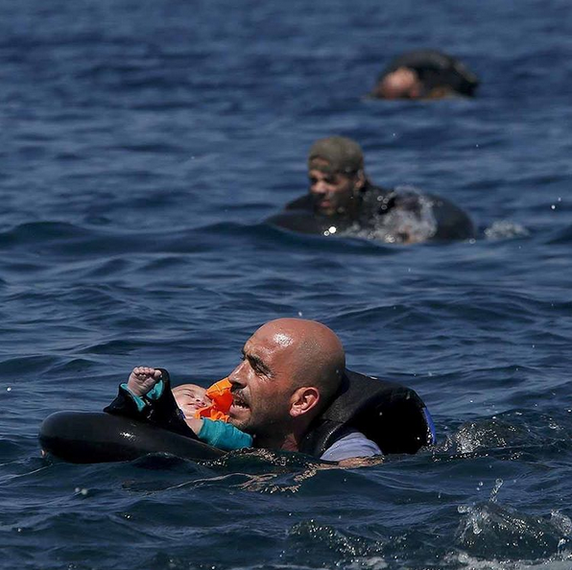
A Syrian refugee holding a baby in a life tube swims towards the shore after their dinghy deflated 100m away from the Greek island of Lesbos, September 13th 2015. According to the International Organisation for Migration over 400,000 refugees and migrants have made the journey across the Mediterranean to Europe so far this year^{[11]}.
Credit: Reuters/Alkis Konstantinidis #refugees #migrants #Greece #Lesbos

***
Turkey 'acting illegally' over Syrian refugees deportations^{[12]}
Mark LowenBBC Turkey correspondent
15 January 2016
The BBC team met Ahmad at Tekirday detention camp.
‘’We first met Ahmad in September on the Turkey-Greece border in the town of Edirne. He was among 2,000 Syrians who had camped out at the local stadium there, trying to travel legally across the land border into Greece, rather than risking their lives in overcrowded rubber boats. After a few days, they were cleared away by police. But not all obeyed. About 120 vowed to stay put.
'I would rather die'
Deemed "troublesome", they were rounded up by police and taken off by bus. We followed as they arrived at the local detention camp. The policemen refused to tell us their final destination. Through the railings, dozens of inmates already there shouted from their windows, one gesturing that his arm had been broken. Suddenly we lost the mobile phone contact that we had kept with a handful of them. In early December, Ahmad got in touch. He was in a new detention camp, he said, in Tekirdag - a two-hour drive from Istanbul. The Tekirdag detention centre is about a two-hour drive from Istanbul "And what of the others?" I asked."They were sent back to Syria," he replied. Under the "non-refoulement" principle of international humanitarian law, a state is prohibited from deporting individuals to a war zone. We decided to visit Ahmad in Tekirdag to hear more of the allegations that Turkey is acting illegally. "I was beaten badly in Edirne," he said. "They hit me." He passed us a photograph, which shows heavy bruising on his leg. It was caused, he said, by mistreatment at the hands of the guards. Ahmad says he was "beaten badly in detention" After Edirne, he was taken to three other camps - in Aydin, Erzurum and now Tekirdag - with no prospect of a trial. "Did the others want to go back to Syria?" I asked."No. I'm absolutely sure that most of them were running from Syria." What would he do if they tried to send him back? "I would rather die".
'Forced us to sign papers'
Two other members of the group arrested in Edirne also made contact. One, from the Islamic State (IS) stronghold of Raqqa, messaged with the words: "We are out of prison today. They sent us to Syria. "Bye my friend. Don't write to me until I do please," he wrote, clearly fearful of retribution by IS.We tracked down the other to southern Turkey, where he said he had returned after being deported to Syria in late November. He showed us the Turkey exit stamp on his passport. The border at Kilis is the one of the main crossing points between Turkey and Syria "They drove us to the border and forced us to sign a piece of paper on which was written 'I want to go back to Syria'," he told me. "They were shouting at us and said they would send us back to Erzurum (detention centre) if we didn't sign. "I didn't want to go back to Syria. Some of my friends have now been put in prison there, and many people were afraid of returning to a war zone."
'Absolutely illegal'
More than two million Syrians are now in Turkey - it is the largest host of refugees in the world.
Many are settled here, glad of sanctuary. But others are using it as a transit to Europe. Of the more than one million migrants and refugees who travelled to the European Union in 2015, most have come through Turkey. The Turkish government has now signed a deal with the EU to receive about.€3bn (£2.2bn; $3.3bn) to stem the flow. But that is contingent on improving conditions for refugees so more feel they can stay here, not deporting them back to a war zone.
...
Amnesty International says its research has found that scores - possibly hundreds - of refugees and asylum-seekers have been sent back to Syria and Iraq."This is absolutely illegal, both under Turkish and international law, because you cannot forcibly return someone to a place where their lives and rights are in danger," said Andrew Gardner, the head of Amnesty in Turkey.
Grave charges
We asked the Turkish government for an interview. They declined, but issued this statement:"We categorically deny that any Syrian refugees have been deported from Turkey to Syria... The UNHCR (United Nations refugee agency) interviews all returnees at the border to make sure they're going to Syria voluntarily."When we replied, telling them our interviewees spoke of being forced to sign voluntary return papers, they replied: "To ensure public safety, individuals with criminal ties may be asked to reside at a refugee camp. If certain individuals would rather return to Syria… the government can't forcibly keep them in Turkey".But Ahmad is being forcibly held in Turkey, and we have seen no evidence that the group arrested in Edirne had "criminal ties".Covert detention, deportation to a war zone: the charges are grave.A country that has warmly and proudly welcomed so many Syrians now stands accused of illegal acts.
***
Migration into Europe
A surge from the sea^{[13]}
Illegal migration is causing strains across the continent
Aug 14th 2014, 14:59 | From the print edition
ANOTHER weekend, another two thousand-odd immigrants rescued by Italian sailors and coastguards in the Mediterranean. On August 11th the San Giusto, an amphibious transport vessel, landed 1,698 people in Reggio Calabria, a city in southern Italy. The day before, a naval patrol vessel and a frigate disembarked 364 people at ports in eastern Sicily.
The number of people arriving in Italy by sea this year may already exceed 100,000. By the end of July approximately 93,000 migrants had been rescued. The previous record for an entire year was set in 2011 when around 60,000 people reached Italian shores at the height of the Arab Spring.
The sudden jump in arrivals is related to turmoil in Libya, from where most of the migrant-trafficking vessels depart. Another reason is the Italian government’s maritime search-and-rescue operation, Mare Nostrum, launched last October after 368 Eritreans and others drowned off the island of Lampedusa. The prospect of being picked up by the Italian navy has made the journey on an overloaded and often barely seaworthy vessel seem less scary.
...
Even so, the Italians need help. Thanks partly to the Dublin regulation, which says that the first European Union state where a migrant arrives, his finger prints are stored or an asylum claim is made, is responsible for the claimant, Italy is one of the five EU countries that get 70% of all asylum applications (Germany, Sweden, France and Britain are the others). Ministers have repeatedly and fruitlessly sought EU involvement in dealing with the Mediterranean influx. Most recently, the interior minister, Angelino Alfano, proposed that the EU’s border-management agency, Frontex, should take over the running of Mare Nostrum. But Frontex’s operational budget for 2014 is a mere €55.3m ($74m) and Mare Nostrum costs €9m a month.
Moreover, Warsaw-based Frontex is solely focused on border security. In Greece it blocked the land route across the Evros river marking the Greek-Turkish border with a 12km (7.5 miles) metal fence. As a result, a tide of desperate migrants are increasingly using the sea route from Turkey to the eastern Aegean islands, which is shorter than that from northern Africa to Italy, yet full of hazard.
Migrant arrivals by sea doubled in the first six months of this year to more than 25,000, according to Greek police, though this number only covers those they picked up. Most of the new arrivals were Syrians and Iraqis, often families with children. Traffickers use small boats to reduce the chances of being picked up on a Greek patrol boat’s radar, but that has costs. Rough seas are frequent, churned up even in summer by strong northerly winds. Many boats capsize. The luckier migrants are dropped off on stretches of inaccessible coastline, or left to drift ashore.
Undocumented migrants are not usually assisted by the Greek coastguards, unless their boat capsizes. The UNHCR, the UN’s refugee agency, has voiced concern about “pushbacks”, the coastguards’ practice of towing migrant boats back into Turkish territorial waters. Twelve people died in January when a boat carrying 28 migrants overturned while being towed at high speed by a coastguard vessel.
“These informal forced returns to Turkey are in violation of international human-rights legislation,” says a UNHCR official in Athens. Around 100 such pushbacks happened in the past nine months, according to the UNHCR. The Greek merchant marine ministry denies they take place.
Those who make it to Greece risk being detained in a closed camp to await deportation. Some 6,000 migrants are held in half a dozen camps. Médecins Sans Frontières, a charity, recently reported untreated cases of scabies and hepatitis among inmates. Hundreds more are held in filthy, overcrowded cells at police stations. This year the 18-month limit on detention for migrants was extended indefinitely.
Peripheral countries are where many illegal migrants first touch European soil. This week more than 1,200 illegal migrants crossed the sea from Morocco to Spain within two days. But Spain or Greece is often not where they stay. Their ultimate destination is usually further north.
...
No one knows how many undocumented migrants live in France. An estimate of 200,000-400,000 bandied about six or seven years ago is not improbable. Last year the authorities had before them almost 66,000 requests for asylum and granted asylum or other protection to fewer than 11,500. Refused asylum-seekers often stay on illegally, or try to make their way to another country.
The port of Calais in the north is a favoured way station for people hoping to scramble into the back of a lorry bound for Britain. On May 28th French police cleared out three makeshift camps where around 700 illegal migrants—most of them Afghan, Syrian, Somali, Sudanese and Eritrean—were staying. On July 2nd they turfed over 600 more out of three squats and a feeding centre. In the first six months of the year 7,414 undocumented migrants were arrested in Calais, more than double the 3,129 detained in the same period of 2013, says the local préfecture.
Since Nicolas Sarkozy, the then interior minister, closed the Red Cross centre in Sangatte in 2003, northern France has not had any organised facility for migrants. France cannot stop people from crossing its territory if they come in from another Schengen country. But Britain does not belong to Schengen and is neither obliged nor inclined to take them. Natacha Bouchart, mayor of Calais, says Britain’s generous welfare system is the magnet. In fact it is more likely to be its lack of identity cards and stringent labour inspections.
The costs of generosity
Further north still, Sweden stands out for being particularly welcoming to asylum-seekers. In September 2013 it became the first EU member to grant permanent residence to all its Syrian refugees. Over 8,000 Syrians filed for asylum in the first five months of this year. According to a report by Eurostat, the EU’s statistics agency, published in June, Sweden, with its relatively small population of 9.5m, took in 12.5% of the EU’s total of 435,000 asylum seekers in 2013. The bulk of these were from Syria.
Sweden’s generosity was widely lauded, even by the pope, but the strains are showing. Refugees now face waiting times of up to a year for asylum-application interviews in Swedish embassies, and Swedish authorities say they lack the resources to deal with incomers. Sweden, like Germany and France, complains that it deals with more than its fair share of asylum-seekers. But that is no comfort to the poorer countries to the south that lie in the way of many arrivals.
***

Two children drown every day on average trying to reach safety in Europe^{[14]}
News Stories, 19 February 2016
Marco Procaccini in Kos, Greece
In a joint statement, issued in Geneva, UNHCR, UNICEF and the IOM warned that the number of child deaths was on the increase and called for more measures to increase safety for those escaping conflict and despair.
Since last September, when the tragic death of toddler Aylan Kurdi captured the world's attention, more than 340 children, many of them babies and toddlers, have drowned in the eastern Mediterranean. The total number of children who have died may be even greater, the sister organisations said, with their bodies lost at sea and never recovered.
One of those statistics was seven-year-old Houda from Afghanistan who went missing in a shipwreck off the Greek island of Kos at the end of January. Her mother, father, two sisters and one of her brothers had left Kabul for Istanbul earlier that month after her father, a middle-ranking police officer, received death threats.
In Turkey, the family made a deal with a smuggler who promised them an "extra-safe trip in a spacious large boat" to Greece. To pay for the trip, Houda's father had sold his house and borrowed money from family and friends.
At night in a dark bay as they prepared to leave, they saw the boat was little more than a sailing coffin. It was small, old and massively overcrowded with around 80 passengers covering a few metres of deck.
They tried to step back, but were forced by the smuggler to board the boat with no questions. Smugglers allow no last-minute change of mind.
Houda's sister Aisha and her brother Aziz survived that deadly trip, along with 26 others, but her mother, father and an older sister perished. Their bodies were recovered. Houda's was never found. Aisha and Aziz, 16 and 15 respectively, had learned to swim in school and that saved them.
The stretch of the Aegean Sea between Turkey and Greece is now among the deadliest routes in the world for refugees and migrants.
"These tragic deaths in the Mediterranean are unbearable and must stop," said UN High Commissioner for Refugees Filippo Grandi. "Clearly, more efforts are needed to combat smuggling and trafficking. Also, as many of the children and adults who have died were trying to join relatives in Europe, organising ways for people to travel legally and safely, through resettlement and family reunion programmes for example, should be an absolute priority if we want to reduce the death toll," he added.
With children now accounting for 36 per cent of those on the move, the chance of them drowning on the Aegean Sea crossing from Turkey to Greece has grown proportionately. During the first six weeks of 2016, 410 people drowned out of the 80,000 people crossing the eastern Mediterranean. This amounts to a 35-fold increase year-on-year from 2015.
Aisha and Aziz are now accommodated at a transit facility UNHCR runs with a national NGO offering specialized services to unaccompanied refugee children in Greece until they are assigned to a permanent facility. They wish to reunite as soon as possible with what remains of their family. They have a brother in Germany and hope one day to be able to join him there.
"These children expressed incredible dignity and courage throughout the many challenges they faced after the shipwreck. After already identifying the corpses of his own family members at the Coast Guard, Aziz insisted on seeing more pictures in order to recognize fellow travellers and help in their identification so that their families could also find out what had happened to them. They repeatedly expressed their gratitude towards me and other colleagues for the help we provided," said Georgios Papadimitriou, a senior protection officer with UNHCR.Marco Procaccini, UNHCR's Head of Office in Kos, said: "I was impressed by the resilience and the courage of Aziz and Aisha since we met them at the port where they were brought by the Coast Guard vessel which rescued them that terrible night. Despite going through the worst we can ever image for a child, they remained always polite and kind."Aziz thanked UNHCR, other NGOs and the local volunteers that supported him and his sister during this difficult time and said one day he would return with the rest of what remains of the family to visit the graves of those who were found and also say a prayer for Houda.
***
What happens after refugees arrive in Greece^{[15]}
The Economist visits the only operational “hotspot” in the country
Feb 5th 2016,LESBOS,Europe
SINCE the number of migrants making their way to Europe through Greece ballooned in 2015, Greek and EU officials have been scrambling to cope. Late last year EU officials hit on the idea of a series of “hotspots”—centres where migrants are registered—to try to bring order to the chaos. Three have since opened in Italy (though only the one on the island of Lampedusa is fully functional) and one on the Greek island of Lesbos. On January 31st Greek officials said that, after months of delay, the country would get on with opening four more on the other islands; they claim all will be open by the spring. This week The Economist went to the one in Lesbos. What is it like, and does it work?
The Greek hotspot is in the Moria camp, a former military base about 15 minutes north of Mytilene, the biggest town in Lesbos. Outside the camp is the “Afghan hill”, where around a dozen tepees are set up and migrants, mostly from Afghanistan, wait to be bussed to the ferry that will take them to Athens. It is all rather ad hoc—with makeshift fires, signs made by volunteers advertising free stuff, and a playground for children.
Inside the camp it is rather different. The hotspot is sealed off by a tall metal fence and guarded by police. The facility is divided into three sections. The first, and largest, is for all Arabic-speaking migrants (mostly Syrians). The second is for Afghans and other Farsi-speakers; the third is for the few migrants who have applied to be transferred to other European countries under the “relocation” scheme which the EU launched last year.
At the first site migrants wait in a huge white tent (which can hold around 400 people). From there they are taken in groups of 20 or so to a series of metal huts with corrugated roofs and bars on the windows. In the first room, three screeners and three interpreters seated at plastic tables quiz the migrants to find out where they are from, and inspect their passports or papers for forgeries. The migrants then proceed to a second hut, where a dozen officers of Frontex, the EU’s border agency, operate fingerprint machines. Finally, in a third hut, the migrants are photographed by Greek police officers and given temporary visas which allow them to stay in Greece for either 30 or 180 days (depending on their nationality). For a single man, the entire process takes about half an hour.
Once the migrants have a temporary visa, they can either claim asylum in Greece or leave. Most leave. They buy a ticket on a ferry organised by the Greek authorities and go to Athens. From there, they will continue on through Europe.
The process is fairly thorough. Without a temporary visa, the migrants cannot board the ferries. Fingerprint data go to Eurodac, the European database. And not all migrants are let through. Those who turn out to be Algerian, Moroccan or Tunisian, or who are flagged up as a security threat, are apprehended and sent straight to Athens, where they must either claim asylum or be placed in a holding centre and returned to their home countries. (In theory, at least; some north African migrants may fall through the cracks.)
But the system is not without its flaws. One of the screening rooms is adorned with mugshots of migrants who sold their temporary visas and re-registered themselves. Some migrants buy forged documents from criminal gangs as soon as they land on the island (although Frontex claims that its coast guards have caught or scared off many of the gangsters).
Most importantly, the hotspot grapples only with the first stage in a long process. Migrants can register there, but they cannot apply for asylum in Europe while on the island unless they go through the relocation scheme, which few do. Instead they go to Athens (from which most leave, waiting until they get to Germany or Sweden before they claim asylum). This means that cracks open up in the system. People who may be economic migrants, or from stable countries, are being funnelled through to the mainland, where some may buy fake papers identifying them as Syrian and try their luck getting to Germany.
To work more efficiently, the hotspot concept needs to be expanded. It would help if Greece got on with building the rest of them—the one in Kos has been held up by squabbling politicians and local NIMBY resistance. Other sites have problems with electricity or toilets. The existing one in Lesbos could also be made bigger and better: although the number of Frontex officers was recently increased, they still find it hard to cope with the sheer numbers of asylum-seekers at peak times.
...
***
Asylum-seekers, economic migrants and residents of all stripes fret over their place^{[16]}
Aug 29th 2015,BRUSSELS, HELSINKI AND WARSAW
FINLAND, with its baffling language and culture of reserve, is not an easy place for outsiders to penetrate. For Nura Farah, the breakthrough came via the dissected brains of dead cows. Ms Farah, who arrived with her mother in 1993 as a teenager seeking asylum from Somalia’s civil war, spent eight years dreaming of a better life in London while she was taunted at school and bore racist abuse on the streets. But in 2001, working as a lab technician in Helsinki, she found herself charged with testing cow tissue for bovine spongiform encephalopathy, or mad-cow disease. The work was fulfilling, her colleaguesencouraging, and she moved on to bigger challenges. She took on Finnish citizenship, gave birth to a son and last year became the first Somali Finn to publish a novel.
Finland is a long way from the migrant trouble that has erupted across Europe this summer. But as a country with little history of immigration that has had to integrate an unfamiliar minority, its experience resonates. Most EU countries will soon start receiving asylum-seekers from Italy and Greece, the main entry-points for illegal migrants. Many residents, particularly in Europe’s eastern half, resent this intrusion. Yet Europe’s migrant crisis has seemingly outgrown national responses.
Not since the second world war has the continent faced refugee flows of such complexity and scale. Smugglers are exploiting the political vacuum in Libya to transport Africans across the Mediterranean to Italy. Refugees from Syria’s civil war clamber into rubber dinghies at Turkish ports to reach Greek islands. Then they traverse the continent by the thousand, causing havoc at borders and leaving officials to choose between haplessness and brutality. Migrants who have endured the savagery of the Islamic State or the caprice of Eritrea’s police state find themselves tear-gassed by Macedonian police or evading the clutches of French security guards.
The raw numbers
Around 270,000 illegal migrants have reached Europe’s shores so far this year, more than in the whole of 2014, itself a record year. These numbers should be manageable in a continent of 500m; but asylum-seekers’ preferences for certain parts of Europe over others create pinch points at borders and tensions between governments. Some have resorted to security measures to keep migrants out; others speed their passage to the next state. What such responses share is a wish to pass the problem on. The current crisis is testing, and fracturing, that approach.
European Union officials in Brussels are searching for a common migration policy. Their first success, after 800 would-be migrants drowned off the Libyan coast in April, was to persuade Europe’s leaders to triple Operation Triton, a border-surveillance mission that operates south of Italy. Tens of thousands of migrants have been picked up since then; 4,400 on one day, August 22nd. After a shocking beginning to the year the death rate has plummeted.
But migrants are adjusting their routes. The big change this year is the number entering Greece via short sea hops from Turkey. Syrians in particular have been put off the Italian route by the chaos in Libya and the dangers of the sea. The Greek government, which has other things on its mind, needs help processing the arrivals and wants many to settle elsewhere. In May the European Commission proposed relocating 40,000 asylum-seekers from Greece and Italy to other EU countries (Britain, Denmark and Ireland have opt-outs from such matters), with national quotas determined by a formula incorporating population, GDP, unemployment and previous asylum bids and resettlements. But opposition from eastern Europeans and Spain squashed the plan.
Instead, most countries have volunteered to accept a certain number of relocated asylum-seekers, amounting to 32,256 over the next two years; the EU hopes to reach 40,000 by the end of the year. As with the original plan, eligibility is limited to migrants arriving in Italy and Greece from mid-April who hail from countries with asylum acceptance rates in Europe of over 75%: for now that means Syria, Eritrea and perhaps Iraq. The programme may be operational in October, though logistical problems could delay the start in Greece. Less controversially, European countries, working with the UN refugee agency, will resettle 22,504 people from outside Europe who already have refugee status. Most will probably be Syrians currently languishing in Jordan, Lebanon and Turkey.
These numbers are puny next to the scale of the problem: almost 50,000 asylum-seekers reached Greece in July alone. Some 4m Syrians have fled their homeland, not to mention the Sudanese, Somalis and others in camps in Africa who are also candidates for resettlement—or may decide to try their luck at the border. Yet by EU standards, this is progress: the Triton expansion and the relocation plan erode the notion that asylum-seekers are the sole responsibility of the country they reach first.
Europe has coped with emergencies before. The Yugoslav wars of the 1990s generated vast refugee flows that Germany and others were able to manage. After the Vietnam war France accepted around 100,000 boat people. Yet today many central and eastern European countries balk at calls to accept even a few hundred migrants. Some argue, plausibly, that new arrivals will simply up sticks as soon as they are relocated, exploiting the passport-free Schengen area to rejoin family in Sweden or find work in Germany. Poland’s government, facing re-election in October, is torn between a Europe demanding solidarity and a sceptical electorate; 70% oppose taking in asylum-seekers from Africa or the Middle East.
Some have more atavistic concerns. Slovakia wants Christian refugees only. Hungary’s prime minister, Viktor Orban, portrays his country as a doughty defender of European values in the face of an invasion by people from “different civilisational roots” and the “intellectual derangement” of liberals who want to let them in. His government is building a fence along the border with Serbia to keep out the wretches traipsing up from Greece and Macedonia. Ban-the-burqa debates have sprung up in the three Baltic states (combined population 6.2m), which together will accept 725 refugees.
Many easterners fear that outsiders will bring with them unwelcome values and habits. Some look at crime-ridden French banlieues or segregated Swedish cities like Malmo and see a future they wish to avoid. Finland shows how easily short-term refugees may become long-term residents. Thanks to family-reunification rules and the magnetic pull of the diaspora, there are now more than 16,000 Somalis in Finland, up from 49 in 1990, making them the country’s third-largest minority, after Russians and Estonians. Somalis account for one-quarter of asylum applicants in Finland this year, but just 2% across Europe.
It may seem fanciful to imagine Syrians or Eritreans putting down roots in Poznan or Presov. (It may not happen, if enough asylum-seekers break the terms of their relocation and move on.) But no doubt something similar could have been said about Helsinki three decades ago. Overwhelmed by the “Somali shock” in the early 1990s, and in the midst of recession, Finnish authorities had to improvise. Instant responses, like building reception centres and crackdowns on overt racism, gave way to integration policies such as language classes and measures to ease Somalis into the workforce.
Today the picture is mixed. Somalis tend to appreciate Finland’s peace and the freedom it affords their Muslim faith. Finland’s enlightened social-housing policy, which aims to ensure mixed neighbourhoods, stops or at least slows the development of Sweden-style ethnic ghettoes. But Finnish children with immigrant backgrounds struggle at school (see chart). In 2012, 38% of young Somali men in Helsinki were neither in work nor education. And Finnish identity has not, by and large, found space for the Somalis. Intermarriage is rare. Ambitious Somalis move abroad. When Finland’s biggest newspaper included her novel in a list of books to watch, Ms Farah’s delight quickly soured when she saw she had been described as Somali rather than Finnish.
Without much recent history of immigration to draw on, eastern European hosts will have to learn the lessons of integration quickly. The EU will pay countries €6,000 ($6,900) per asylum-seeker. But language lessons must be organised and reception centres prepared. Schools have to make specific provisions for children, some of them traumatised, while helping them integrate with their peers. Citizens living near reception centres will need reassuring. NGOs must be mobilised. Perhaps most importantly, governments must ease the passage of adults into the workplace, the best motor of integration. This might mean tinkering with laws. All this takes planning and political will. “You need to start yesterday,” says Annika Forsander, who ran Helsinki’s integration office for seven years.
Yet few eastern European governments have an interest in seeing the experiment succeed. For if it does, Brussels will have a better chance of pushing through a mandatory relocation scheme; the commission plans to revive the idea, with a few tweaks, early next year. Why might the second plan succeed when the first flopped? Pressure from Germany, groaning under an expected 800,000 asylum claims this year, is one reason. Angela Merkel, the chancellor, describes the migrant crisis as “the next great European project”. This week she teamed up with François Hollande, the French president, to urge action; a sure sign she wants to get something done.
Logistically the Germans will cope with their migrants, thanks in part to an efficient domestic relocation plan that helped inspire the EU version. But the government frets about a political backlash; thugs have torched lots of refugee homes and the moans from regional officials are growing louder. The EU’s relocation plan is presented as a way to relieve Italy and Greece, but it may also be an effort to reduce the burden on Germany and other popular destinations, such as Sweden and Austria. Further rows lie ahead.
The tough approaches some governments take to illegal immigration spring from a reasonable concern: they want to choose their migrants rather than the other way around. Economic migrants and asylum-seekers journey together. Often they are the same people—a Syrian refugee may wish both to avoid decapitation and to earn higher wages. (Still, nearly two-thirds of the migrants to reach Europe this year are from countries so dangerous that their nationals are usually granted asylum.) Security services must be alert to the possibility of terrorists exploiting well-trodden migration channels. Assembling fences, mobilising troops and dispatching drones is therefore tempting. Yet it sits awkwardly with Europeans’ self-imposed obligation to offer protection to anyone with a well-grounded fear of persecution. And it often merely displaces the problem from one country to another.
...
As outsiders appear ever more desperate to enter Europe, its residents seem ever-keener to keep them out. A recent Eurobarometer poll found immigration at the top of voters’ concerns for the first time in the survey’s 42-year history. Populist parties with anti-immigrant streaks are on the rise: last week the Sweden Democrats, a nationalist party with neo-Nazi roots, topped a poll in Sweden. It is hard to imagine a policy that would play into the hands of such outfits better than a diktat from Brussels to accept more Muslim refugees. Last month Olli Immonen, a potty-mouthed Finnish MP, called on his countrymen to “defeat this nightmare called multiculturalism” (foreigners account for 5.9% of the Finnish population). Finland’s Somalis say the climate has grown frosty.
To help secure the support of voters for more generous asylum rules, EU officials still have cards up their sleeves. Next year they will review the Dublin rule, which in theory obliges asylum-seekers to make their claims as soon as they enter Europe; in practice it is a shambles. The EU also promises to clamp down on Italian and Greek officials, who are supposed to register asylum-seekers on arrival but tend to nod most through.
...
In the longer term, leaders will have to talk to their people about demography. Within ten years, according to Bruegel, an economic think-tank, Europe’s labour force will start shrinking. Africa, meanwhile, is growing apace; by 2050, the UN projects that its population will be well over three times that of Europe, up from around 1.5 times as big today, and far younger. Europe could do with some sprightly immigrants to boost its tax base and pay for its growing army of pensioners.
...
Hope nonetheless
That may be no bad thing: Europeans should compete for foreign talent rather than form a monopoly buyer. But the domestic politics are hard. Finland, which experienced a baby boom earlier than most other European countries, has an ageing and declining labour force. But the success of anti-immigrant politicians has diminished the prospect of importing labour. Still, politics can change as countries grow richer. Over the years Spain and Ireland have come to see themselves as countries of immigration rather than emigration. Germany may be inching closer to passing a comprehensive migration law that goes beyond the old guest-worker schemes.
Amid all the wrangling, one should not overlook the benefits to migrants, even if they emerge in unexpected ways. Fadumo Dayib, who arrived in Finland in 1990, speaks extremely warmly of her adopted nation, but to fulfil her ambitions she had to move on somewhere else. Having spent the past year studying at Harvard she is now planning to run for the presidency of Somalia. Even migrants who struggle to take on their adopted homeland’s identity are surprised to find it suddenly materialise when they travel. A few years ago Ms Farah visited London but, confronted with its bustle and noise, found herself craving the quiet of her Helsinki suburb.
***
Entering the U.S. as refugees would be the hardest way for would-be terrorists^{[17]}
By Jeremy Diamond, CNN / Updated 0315 GMT (1115 HKT) November 21, 2015
Washington (CNN)
Even before the debris from the Paris terrorist attacks was swept away, politicians began sounding the alarm that Syrian refugees could be a national security threat to the United States. The issue has dominated the U.S. political conversation during the week since gunmen and suicide bombers terrorized Paris on a Friday night.
All Republican presidential candidates called on President Barack Obama to renege on his pledge to admit 10,000 refugees fleeing Syria's brutal civil war into the U.S. and argued instead for a full stop, fearing terrorists could infiltrate their ranks.
Thirty-one governors have declared Syrian refugees unwelcome in their states and on Thursday the House passed a bill to bar refugees from Syria and Iraq from entering the U.S. Nearly 50 Democrats joined 242 Republicans to pass the bill, which the White House has threatened to veto. Sen. Ted Cruz, a Republican presidential candidate, suggested the U.S. only accept Christian refugees. Ben Carson, another candidate, likened refugees to "rabid dogs" threatening the neighborhood
But those responses ignore one very important fact: the refugee program is quite simply the toughest way for a foreigner to legally enter the United States. There are other security gaps that would be easier for would-be terrorists to exploit.

Were any of the Paris attackers refugees?
...
A Syrian passport found next to one of the attackers' bodies stoked fears that the man had been a refugee. That has not yet been confirmed, although top European officials have suggested the passport was doctored, which raises its own set of questions, but does not confirm the suspected attacker was a refugee. Others have definitively been shown to be European citizens.
Perhaps more importantly, the European refugee admission system is dramatically different from the U.S. system for Syrians, in large part because the U.S. is geographically separated from Syria. The U.S. has the opportunity to do far more vetting before refugees arrive on their shores.

How does a refugee get into the U.S.?
Refugees must undergo an 18- to 24-month screening process, minimum, that the United Nations' refugee arm oversees. And that's before individual countries even begin to consider a refugee's application and conduct their own additional interviews and background checks.
The screening process generally includes multiple interviews, background checks and an extensive cross-referencing process that tests refugee's stories against others and accounts from sources on the ground in their home country.
Throughout that process, U.N. officials and local government officials in temporary host countries like Turkey, Jordan and Lebanon look to determine the legitimacy of asylum seekers' claims and ensure that they meet the criteria of a refugee, including that they are not and have not been involved in any fighting or terrorist activities.
Refugees also have their retinas scanned and have their fingerprints lifted.
Christopher Boian, a spokesman for the United Nations High Commission for Refugees, called the process "stringent" and "long and complex''
Refugee: 'I would be dead' if still in Syria "If at any stage in that process there is ever the slightest shadow of a doubt or the slightest whisper of suspicion, they are removed from the process. That is that," Boian said. "The very, very few Syrian refugees who are accepted and referred for consideration for resettlement in another country -- there simply is no more closely scrutinized population on earth these days," he added.That's because other countries have so far pledged to resettle just 159,000 of the more than 4 million Syrian refugees -- setting an extremely high bar for resettlement.
And refugees aren't automatically considered for resettlement: only the most vulnerable refugees -- such as torture victims, female heads of household, people with serious medical conditions and other especially vulnerable groups.
So after they go through that process by the U.N., the U.S. does an additional screening?
That's right. After a rigorous screening process and several interviews carried out by the U.N. refugee agency, refugees the U.S. agrees to consider for resettlement have to undergo an additional interview, medical evaluation and security screening.
According to one U.S. government official, there's an additional layer of vetting that's specific to Syrian applicants, including special briefings for interviewers and information from the U.S. intelligence community.
The security screening involves checks against several government agencies' databases and terrorist watch lists using biographic and biometric information. It's a process Mark Toner, a State Department spokesman, recently called "the most stringent security process for anyone entering the United States."
And Syrian refugees get an additional, more targeted layer of screening involving the U.S. Intelligence agency, according to a government official.
How do Syrian refugees get into the U.S.?
How does the refugee process stack up to other ways of getting into the U.S.
The refugee program is simply the toughest way for any foreigner to enter the U.S. legally.
For most people, getting a tourist visa to enter the United States is much easier, but still requires an in-person interview...
The fact that most of the Paris attack suspects were European citizens who would have had access to the visa waiver program is setting off some alarm bells. At least one of the eight Paris attackers likely would have been able to travel to the U.S. under the visa waiver program, U.S. national security officials told CNN Friday.
Angus King: Visa waivers bigger danger than refugees
As a sign that the Obama administration agrees that there are gaps that need closing, one of the U.S. officials said, in the coming days the administration expects to announce plans for additional steps to be taken with European countries that participate in the visa waiver program.
Sen. Angus King, an independent from Maine who sits on the intelligence committee, said it "would be much harder" for a terrorist to get into the country through the refugee program than with a passport from one of the 38 countries in the visa waiver program.
"(The refugee process) would take 18 months to two years. Under the visa waiver program, it could take 24 hours," King told CNN in a phone interview. "The target of our work should be strengthening the visa waiver program."
"We do need to pay attention to whether the terrorists could infiltrate the refugee flow. I don't think it's something we should ignore, but the amount of vetting that goes on there already is very through," King added.
So is that program getting strengthened?
A bipartisan proposal to do just that is gaining momentum on Capitol Hill.
Noting that 20 million people each year use the visa waiver program to visit the United States, Sen. Dianne Feinstein, D-California, said in a Thursday news conference that a bill she is proposing with Sen. Jeff Flake, R-Arizona, would help guard against terrorists trying to exploit the program.
"Terrorists could exploit the program, could go from France to Syria, as 2,000 fighters have done, come back to France, use the visa waiver program and without further scrutiny come into the United States," said Feinstein, a senior member of the intelligence committee.
The Feinstein-Flake bill, which is set to be formally introduced after Thanksgiving, would keep foreigners who've traveled to Syria or Iraq in the last five years from using the visa waiver program. It would also mandate fingerprinting for all travelers entering the U.S. from visa waiver countries and requires all foreigners from those countries to have a modern passport that has an embedded e-chip that is more secure and includes an individual's biometric information and other data.
Flake, the bill's Republican sponsor, told reporters Thursday the refugee program could be strengthened to include better tracking of refugees once they arrive in the country, but said touted the rigorous process as something that shouldn't be a source of concern.
"On the front end, it is a very thorough vetting that they get. So of all the things that we ought to be concerned about, that is not at the top of the list," he said.
CNN's Evan Perez, Pamela Brown, Shimon Prokupecz and Scott Glover contributed to this report.
***
Will Germans embrace or shun refugees?^{[18]}
By Catrin NyeBBC News, Gera, Germany /11 December 2015
- Tens of thousands of Syrian refugees are being dispersed throughout Germany. One family in the east of the country describe how their small city is adapting to life alongside the country's new residents.
- In a crowded market square in Gera, poets and performers take to the stage. Above them is a banner that has become a familiar sight at train stations across Germany. "Refugees Welcome," it reads in big letters.
- Die Linke, a left-wing German political party, has set up a stall to welcome the newcomers, alongside a local charity.
- A growing crowd of refugees and supportive locals dance around the square to a blasting soundtrack.
Nearby, supporters of AfD - Alternative for Germany - a right-wing group which is cynical about the entry of so many refugees, have gathered.
The AfD party opposes the arrival of so many refugees.It's Saturday afternoon in late.October and Dirk Heinze has come with his wife Daniella Bruhnke and their three children, Sophia, six, Turina, two, and 10-month-old Pierre to hear what both groups have to say.
Dirk, 40, works in care for the elderly and has lived his whole life in Gera. I'm following them as well as some of the refugees to see how they and the city adapt to the changes brought about by the influx of asylum seekers.
Gera was once part of the former German Democratic Republic. It is small, with a population of 95,000, and, until recently, only had 2,000 foreign residents.
Dirk views the groups with scepticism, saying that they are both trying to capitalise on the refugee crisis.Dirk and Daniella explain that they are frustrated at being excluded from decisions that have affected their town. Many residents feel the same, according to Daniella, because the decision to admit so many refugees was made by politicians, without consultation.
The couple haven't been involved in any protests, although they understand why others have. "So many other people are coming. They [the protesters] fear for their jobs. They fear, well, yes for their lives," says Daniella.
In August Angela Merkel said all Syrians could apply for asylum, and wouldn't be sent back to the first safe country they landed in. Germany was already taking a substantial number of refugees.
This week it was reported that the influx of asylum-seekers in Germany has reached the one million mark - four times the total for 2014. About a half of the new refugees are from Syria.
Refugees are being bussed across the country. How many each of Germany's 16 states receives is based on its wealth.
Dirk and Daniella are keen to learn about the refugee situation
Gera is receiving fewer refugees than other cities. Many of them are currently living in the former hospital, converted in mid-October into a refugee centre for up to 2,000 new arrivals.
Someone tried to flood the centre before it opened, so security is very tight. There was also an attack on a refugee by two German men with five dogs in tow. Injuries were minor but news quickly spread around the centre that it may not be safe to go out at night.
The recent influx has caused a mini-political earthquake in Germany. Merkel's approval rating slipped to 54% in December - down from 71% in January.
There have been high-profile and large Pegida (Patriotic Europeans Against the Islamisation of the West) demonstrations against the arrival of Muslim refugees. These have mostly been held in Dresden - about an hour from Gera.
In Gera itself there have been smaller protests known as "Thugida" demonstrations (the name combines Pegida with Thuringia, which is the state in which Gera sits). Daham al-Mohamed arrived in Gera recently from Syria
It's far from one-sided, though. Germans have been filling train stations to welcome refugees - handing out sweets to children and clothes to their parents.
Dirk and Daniella's concerns are always couched with sympathy for those truly in need. "Regardless of which country they come, what religion they are - if someone needs help, they have to receive help," says Daniella.
But she maintains that people shouldn't be allowed to come "just because they want a better life, and because it is better here in Germany".
Dirk is sceptical of Merkel's "Wir schaffen das" pronouncements. The phrase, which means "We will make it", has spawned numerous YouTube mash-ups and memes, some featuring Bob the Builder.
Dirk thinks Germany is taking in so many refugees because of the dark history of the country, "to show to the world that the people here are so-called good people".
In the market square, a man is handing out the Koran. He talks to Dirk about Islam, trying to counter some of the negative things Dirk has heard. He is assured the religion is not aggressive, and that IS does not represent Muslims.
The Syrians I speak to say it's vital that this message is understood. Dirk finds out more about Islam
When I return to Gera in early December, this is a message the city's new Muslims feel they have to push even harder.
The recent attacks in Paris are on everyone's mind - particularly since at least two of the attackers entered Europe posing as refugees. New arrivals in Germany tell me they worry that Germans will come to fear all refugees and that everyone will end up too scared even to communicate, resulting in a segregated city.
"I do believe that the opinion of many people has now changed, because many are afraid now that terrorists will mix themselves among the refugees," says Daniella. "Who knows who is a terrorist and who is a refugee? They don't have it written on their forehead."
These refugees who come from Syria are very ambitiousSandy Mazur, German language teacher
They tell me of other concerns, too. There has been debate for months about lowering the minimum wage in Germany for refugees. It is a controversial idea that, as Dirk puts it, "will keep the big bosses happy", but he fears may lower wages for Germans. Jobs are on everyone's minds here. I spend some time at a German language school.Classes are growing every day because of the arrival of refugees. I meet a language teacher who, though enthusiastic about the potential of the refugees, is not hopeful about their chances.
Sandy Mazur tells me that German is being taught, funded by the government, to a basic level - but after that the money stops.
"These refugees who come from Syria are very ambitious," she says. "They want work - and here in Germany we have so many free work places because we don't have so many young people."
But she says the German provided is not enough to get a job, and certainly not a job in anywhere near in the same professions the refugees worked in back home. Some are teachers, IT professionals and engineers.
As I leave in early December refugees are more visible on the streets of Gera.
Residents are undoubtedly nervous, but many of their foreign neighbours hope they can bring new life to this quiet city.
***
Crossings of Mediterranean Sea exceed 300,000, including 200,000 to Greece^{[19]}
News Stories, 28 August 2015 / By Melissa Fleming, Geneva
GENEVA, Aug 28 (UNHCR)–More than 300,000 refugees and migrants have used the dangerous sea route across the Mediterranean so far this year with almost 200,000 of them landing in Greece and a further 110,000 in Italy.
The UN refugee agency, revealing the latest statistics in Geneva on Friday, said this represents a large increase from last year, when around 219,000 people crossed the Mediterranean during the whole of 2014.
"At the same time, some 2,500 refugees and migrants are estimated to have died or gone missing this year, trying to reach Europe. This death toll does not include yesterday's tragedy off Libya where numbers of deaths are still unconfirmed," UNHCR spokesperson Melissa Fleming told a press briefing in Geneva.
Last year some 3,500 people died or were reported missing in the Mediterranean Sea.
Fleming said that despite the concerted efforts of the joint European search and rescue operation under FRONTEX, which has saved tens of thousands of lives this year, the Mediterranean Sea continues to be the "deadliest route for refugees and migrants".
She added that in the last few days, even more people had lost their lives in three separate incidents.
The Libyan Coast Guard carried two rescue operations on Thursday morning, seven miles off the port town of Zwara. Two boats carrying an approximate total of 500 refugees and migrants were intercepted and survivors taken to shore in Libya.
"An estimated 200 people are still missing and feared dead. A still undetermined number of bodies were recovered and taken to shore. The Libyan Red Crescent has been helping with the collection of the bodies," Fleming added.
On Wednesday (26 August), rescuers coming to the aid of another boat off the Libyan coast found 51 people dead from suffocation in the hold.
"According to survivors, smugglers were charging people money for allowing them to come out of the hold in order to breathe," Fleming detailed.
She quoted one survivor, Abdel, 25, from Sudan as saying: "We didn't want to go down there but they beat us with sticks to force us. We had no air so we were trying to get back up through the hatch and to breathe through the cracks in the ceiling. But the other passengers were scared the boat would capsize so they pushed us back down and beat us too. Some were stamping on our hands."
Fleming said that last week (15 August), the bodies of 49 persons were found in the hold of another boat in a similar but separate incident. They are thought to have died after inhaling poisonous fumes.
Also that week, a rubber dinghy carrying some 145 refugees and migrants ran into trouble when the person steering it made a manoeuvre that caused the dinghy to tilt dangerously to one side.
"Some people fell into the sea and two men jumped into the water to rescue them. Panic ensued and people began to jostle and shove and, as a result, three women were crushed to death on the dinghy," Fleming said.
Of those who fell in the water, 18 are still missing and believed to have drowned. The survivors were rescued and taken to Lampedusa, including a two-month old baby of one of the women who died. Most of the survivors are reported to be in a critical condition, suffering from shock, cuts and bruises.
Many of the people arriving by sea in southern Europe, particularly in Greece, come from countries affected by violence and conflict, such as Syria, Iraq and Afghanistan; they are in need of international protection and they are often physically exhausted and psychologically traumatized.
UNHCR appeals to all governments involved to provide comprehensive responses and act with humanity and in accordance with their international obligations.
All European countries and the EU must act together in response to the growing emergency and demonstrate responsibility and solidarity.

***

Republicans to Obama: Keep Syrian refugees out^{[20]}
By Eric Bradner and Ted Barrett, CNN / Updated 0206 GMT (1006 HKT) November 17, 2015
Washington (CNN)Republicans are putting President Barack Obama and his party on the defensive over accepting Syrian refugees, following reports that one of the terrorists involved in the Paris attacks entered Europe as part of the wave of Syrians fleeing civil war.
GOP governors and lawmakers were quick to announce they wouldn't allow Syrian refugees into their states and are appealing for stronger control of U.S. borders. The issue opens up a firm political line of attack for Republican presidential candidates who had been struggling to find their footing on the national security challenges posed by the Paris slaughter.
...that the United States must remain committed to its values of tolerance and accepting immigrants.
"The people who are fleeing Syria are the most harmed by terrorism," Obama said in Antalya, Turkey, at a meeting of the G20. "It is very important ... that we do not close our hearts to these victims of such violence and somehow start equating the issue of refugees with the issue of terrorism."
Republicans, however, are stressing the security concerns posed by the potential influx of people from the war-torn country. They have called on congressional leaders to block the Obama administration from proceeding with plans to resettle thousands of refugees, with some asking House Speaker Paul Ryan to lead the effort.
...to block funding for any programs "that seek to resettle refugees and/or migrants from Syria into the United States, effective immediately."
Former Arkansas Gov. Mike Huckabee similarly heaped pressure on Ryan, saying in a statement: "Speaker Ryan needs to make it clear that if the President won't stand to protect America from wholesale open borders, then Republicans will."
"If Ryan will not lead and reject the importation of those fleeing the Middle East without assurances that we can separate refugees from terrorists, then Speaker Ryan needs to step down today and let someone else lead," Huckabee said.
In addition, Govs. John Kasich and Bobby Jindal of Ohio and Louisiana, respectively, said they would work to keep refugees out of their states.
And Sen. Rand Paul, another 2016 contender, introduced legislation that would block the United States from issuing visas to refugees from countries with a high risk of terrorism in an effort to "stop terrorists from walking in our front door."

Paul Ryan's strategy on Syrian refugees
Ryan said Monday he has asked the Obama administration to provide a classified briefing for all House members on the situation in Paris. On Tuesday FBI Director James Comey and DHS Secretary Jeh Johnson will deliver a classified briefing to lawmakers, at 5:30 p.m. in the Capitol Visitors Center auditorium. Senators will be briefed on Wednesday.
An aide to the GOP leader said it's not clear when that will take place but it doesn't appear it will be Monday.
In a radio interview with Bill Bennett, Ryan also said he has tasked all committees of jurisdiction to come up with recommendations about how to ensure the thousands of Syrian refugees the President wants to settle in the United States won't be involved in terrorism. Ryan said he was particularly concerned since at least one of the attackers in Paris is believed to have been part of the waves of refugees into Europe from Syria.
"Look, we've always been a generous nation taking in refugees. But this is a unique situation. This is a situation where you have single men coming over, which is not women and children," Ryan said.
Ryan said House leaders are considering adding language opposing the refugees to the large government funding bill that must pass by December 11.
"We've got to make sure we're protecting ourselves," Ryan said. "So that's what we're looking at: What is the best option? Not just so we have an issue to talk about, but so we have a result, which is to make sure we are not complicit or even facilitating of having someone come in who would seek to do us harm from Syria."
Senate GOP leaders are also looking at the question, but no decisions have been made, according to one leadership aide. Classified briefings are also in the works for senators but have not been finalized.
Texas Sen. Ted Cruz made a similar case in South Carolina, saying that "anyone with an ounce of common sense would say 'no, we shouldn't be bringing in tens of thousands of Syrian refugees.'"
"Instead," Cruz said, "we should be resettling them humanely in Middle Eastern countries that are majority Muslim. We can help them deal with their refugee status, but the first obligation of the President needs to be as commander in chief to protect the safety of the United States of America."
As he introduced his legislation, Paul said he wants enhanced screening measures for refugees.
"The Boston Marathon bombers were refugees, and numerous refugees from Iraq, including some living in my hometown, have attempted to commit terrorist attacks. The terrorist attacks in Paris underscore this concern that I have been working to address for the past several years," he said.

Obama responds from Turkey
Obama pushed back against the Republican presidential field Monday and seemed to take particular exception to the sentiments of Cruz -- though not by name.
"When I hear folks say that maybe we should just admit the Christians and not the Muslims (refugees), when I hear political leaders suggesting that there would be a religious test for which person who's fleeing from a war-torn country is admitted -- when some of those folks themselves come from families who benefited from protection when they were fleeing political persecution -- that's shameful. That's not American," Obama said, whose plans currently call for 10,000 Syrians to be admitted over the coming year.
Both Cruz and Florida Sen. Marco Rubio's parents fled Cuba, though only Cruz has mentioned a religious test. Rubio told ABC's "This Week with George Stephanopoulos" this weekend that the U.S. shouldn't accept any refugees from Syria. Former Florida Gov. Jeb Bush said Sunday on CNN's "State of the Union" that the United States should focus on assisting Christians in Syria.
The United States has accepted 2,178 Syrian refugees since the civil war began there in March 2011 -- and that number is expected to grow dramatically in the current fiscal year.
The refugees have been admitted to 138 cities and towns in a total of 36 states -- with California, Texas, Michigan, Arizona and Illinois taking the most, according to wrapsnet.org, where the U.S. government keeps its official numbers.
Louisiana has seen 14 Syrian refugees located there. Ohio has 76 relocated Syrians, while New Jersey, led by 2016 GOP contender Chris Christie, has 88.
The 14 states that have admitted no refugees are Alabama, Alaska, Delaware, Hawaii, Iowa, Mississippi, Montana, Nebraska, North Dakota, Rhode Island, South Carolina, South Dakota, Vermont and Wyoming, as well as the District of Columbia.
...
"Scapegoating an entire religious community and rejecting those fleeing ISIL's terrorism and persecution is what the terrorists want," O'Malley said in a statement.
"We need to step up and act like Americans, in accordance with our principles," he said. "There are women and children dying and fleeing the same sort of carnage that was unleashed on the people of France. This is a time for American leadership, not a time for us to cower."
Two top-ranking Democratic senators backed Obama, too.
Ben Cardin of Maryland, the top Democrat on the Senate Foreign Relations Committee, said the United States has a more stringent vetting process for refugees.
"All the refugees that come to America come from the United Nations refugees' centers and have been gone through by multiple agencies in the United States on background and vetting. It's a totally different circumstance," he said.
And Sen. Robert Menendez of New Jersey said that "we can't stop the idea that we can expect the world to take refugees and we can walk away from it. We should do all of our vetting to make sure and that is why the flow is going to be very slow."

Congress could block funding for refugees
Several influential Republican House and Senate leaders are pushing, too, to block Syrian refugee resettlement.
Sen. Richard Burr, the North Carolina Republican and influential chairman of the Senate Intelligence Committee, said the refugee program "should be suspended until the American people are satisfied that they know exactly who the president is admitting into the country via this program."
Senate Judiciary Committee Chairman Chuck Grassley, an Iowa Republican, offered several specific proposals in a letter to top-ranking Senate budget writers, saying that Congress should "require, as a condition for any funding for refugee resettlement for Syrian refugees, a comprehensive plan on how security will be achieved," included prior vetting by U.S. intelligence officials.
Grassley continued: "Not one dollar should be expended until stringent parameters for vetting these refugees are established."
House Judiciary Committee Chairman Bob Goodlatte, a Virginia Republican, took a more direct shot at Obama in previewing a Thursday subcommittee hearing on the Syrian refugee crisis.
"When will President Obama take ISIS threats seriously, as well as the warnings of national security officials within his own administration, and cease his plan to bring thousands of Syrian refugees into the United States?" Goodlatte said in a statement. "His disconnectedness to reality is needlessly jeopardizing national security and Americans' lives."

Governors move to keep refugees out
Jindal has already signed a state executive order barring the resettlement of Syrian refugees there.
He ordered the state's government to use "all lawful means" to block those refugees from entering Louisiana and authorized the state police to monitor any who are already there.
Jindal's executive order says that "it is foreseeable that the introduction of Syrian refugees into the United States without proper prior screening and follow-up monitoring could result in a threat to the citizens and property of this state."
GOP governors who aren't involved in the presidential race are moving to bar Syrian refugees from their states, too.
Texas Gov. Greg Abbott tweeted that "Texas will not accept any Syrian refugees & I demand the U.S. act similarly. Security comes first." Arkansas Gov. Asa Hutchinson tweeted that he "will oppose Syrian refugees being relocated to Arkansas."
Indiana Gov. Mike Pence similarly ordered his state to suspend the resettlement of Syrian refugees, "pending assurances from the federal government that proper security measures have been achieved."
The Republican governors of Alabama, Arizona, Florida, Georgia, Idaho, Illinois, Kansas, Maine, Massachusetts, Michigan, Mississippi, Nebraska, North Carolina, Oklahoma, Tennessee and Wisconsin similarly moved to stop Syrian refugees from coming into their states.
Iowa Gov. Terry Branstad hasn't attempted to stop accepting Syrian refugees, but a spokesman said that "the governor is requesting that the federal government, who has the authority under the Constitution to decide these matters, be open and transparent with any refugee resettlements."
Democratic governors in Colorado, Connecticut, Delaware, Hawaii, Pennsylvania, Washington and Vermont said they'd continue accepting Syrian refugees, too.
New Hampshire Gov. Maggie Hassan is the only Democrat to oppose Syrian refugees' resettlement in the United States -- a stance that's particularly notable since she is challenging Republican Sen. Kelly Ayotte in 2016. A spokesman said Hassan "believes that the federal government should halt acceptance of refugees from Syria."
***
States cannot refuse refugees, but they can make it difficult^{[21]}
By Ariane de Vogue, CNN Supreme Court Reporter / Updated 0029 GMT (0829 HKT) November 17, 2015
(CNN)A wave of governors -- mostly Republicans -- issued a cascade of press releases Monday voicing objections to Syrian refugees landing their states, following the Paris attacks.
Experts say that while the states may not have the legal authority to block their borders, state agencies have authority to make the process of accepting refugees much more difficult.
"When push comes to shove, the federal government has both the plenary power and the power of the 1980 Refugee Act to place refugees anywhere in the country," said Kevin Appleby, the director of migration policy at the U.S. Conference of Catholic Bishops, the largest refugee resettlement organization in the country.
Appleby said one thing the states could do was to cut their own funding in the area.
American University law professor Stephen I. Vladeck put it this way: "Legally, states have no authority to do anything because the question of who should be allowed in this country is one that the Constitution commits to the federal government."
But Vladeck notes that without a state's participation the federal government would have a much more difficult time. "So a state can't say it is legally objecting, but it can refuse to cooperate, which makes thing much more difficult."
...
"It's been misleading for leaders of States to apply what happened in Paris to would-be refugees who may come to the U.S," Wadhia said. "There is a significant screening process to take before individuals are admitted."
"Refugee admissions are set by the President, and guided by federal law," she said. "States play a role in working with the federal government when refugees are resettled, but the overarching authority rests in federal law."
Additionally, she said, "The people who are coming to the U.S. as refugees are fleeing from the very same perpetrators who committed the acts in Paris. There is a real disconnect and lack of compassion when trying to respond to the Paris attacks by endangering the most vulnerable."
***
China has successfully absorbed many refugees from Vietnam. But it is ill-prepared for another influx^{[22]}
Oct 10th 2015|QIAOGANG, GUANGXI PROVINCE
IN A restaurant in Qiaogang, a town in the southern province of Guangxi, a large poster of Mao Zedong—entitled “Red Sun”—hangs below one of a Vietnamese island where Wu Guangsui, the restaurant’s owner, was born. He fled to China by boat with his family in 1978 when relations between the once-friendly neighbours soured—resulting, the following year, in a brief but bloody war. Mr Wu (pictured), like some 300,000 other Vietnamese who sought refuge in China at the time, feared persecution in his home country for being a member of China’s ethnic majority.
These refugees are among the very few outsiders who have legally settled in China. Then impoverished, China is now the world’s second-largest economy and aspires to be a global power. Its working-age population is shrinking, yet it remains stubbornly reluctant to accept new entrants; thousands fleeing persecution or conflict in North Korea or Myanmar in recent years have faced deportation by the Chinese authorities. Those sent back to North Korea have often been imprisoned and sometimes executed on their return.
It was different with the Vietnamese. At the height of the exodus, 100,000 people entered China through the border town of Dongxing in Guangxi—ten times the local population (see map). Government buildings, homes and schools were emptied to shelter them. They were later settled in six provinces. In 2006 António Guterres, the UN’s High Commissioner for Refugees, described this as “one of the most successful integration programmes in the world”.
The government gave the new arrivals housing and jobs, many of them in state-run farms or factories set up especially for the Vietnamese. Mr Wu was sent to fish in Qiaogang, which means “overseas Chinese port”. It was built as a new village for immigrants. Within a decade many of the Vietnamese had been issued with identity cards and the household-registration documents that entitle holders to government-subsidised education and welfare. Some were given Chinese passports. Most now have full rights as Chinese citizens. The government, however, still classifies them as refugees. It may believe that this will discourage other would-be migrants who are thinking of fleeing to China from believing they will enjoy the same benefits as those who came from Vietnam.
Even the Vietnamese have had difficulties. Many are poorer than Chinese-born locals whose command of Mandarin and better contacts in southern China’s factory boomtowns have given them a leg up. Qiaogang is scruffy and decaying compared with the nearby city of Beihai, which has a forest of shiny new buildings. Some 50km (30 miles) inland at Liguang, one of the many “overseas Chinese farms” where Vietnamese were sent to work, former refugees now make up around a third of the population, but virtually all local businesses are Chinese-run; most Vietnamese remain on the land.
That Mr Wu and most of his compatriots already spoke Cantonese, a language commonly spoken in Guangxi, helped their integration. They belonged to the same ethnic-Han group that makes up more than 90% of China’s population. But they are often still treated as outsiders, even though they have lived in China far longer than they did in Vietnam, and consider themselves Chinese. People in Guangxi refer to them—and their China-born children—as huaqiao, or overseas Chinese. When there are conflicts, says Su Chungui, a Vietnamese farmer in Liguang, townsfolk call them “Vietnam ghosts”. In 2013 Mr Su and some compatriots planted cassava on wasteland to supplement their tiny income. But Chinese villagers destroyed the whole crop before harvest-time, says Mr Su: “We are outsiders, so when we argue, we compromise.” The immigrants did not retaliate.
The arrival of the Vietnamese was a turning point for a country that had long been shut off from most of the outside world, and that had experienced only outward flows since the Communists came to power: thousands of ethnic-Korean Chinese even fled to North Korea in the 1960s to escape famine. In 1979 the UN’s refugee agency, UNHCR, set up an office in Beijing. Three years later China signed the UN’s convention on handling refugees.
Yet China has not yet passed its own laws reflecting the requirements of this treaty. It has no legal definition of a refugee. Aside from the Vietnamese, China has only 583 refugees on its books—most of them from Somalia and Nigeria. This year about 60,000 Burmese poured across the border into China to escape fighting between rebels and government forces. The Chinese government denied UNHCR access to the camps where they were briefly housed. Refugees from North Korea never even get shelter. China calls them “criminals” or “illegal economic migrants”—partly because it remains an ally of North Korea, but also because it fears attracting a lot more of them.
This is less about immediate practicalities: the displacement of around 5m people by an earthquake in Sichuan province in 2008 proved that the government can provide emergency shelter and medical care for large numbers. China worries more about the impact on social stability of a large number of jobless immigrants of different ethnicity from the Han majority. It has little appetite (and cash-strapped local governments even less) for longer-term care. It may need to find one. Should North Korea sink into chaos, the exodus could dwarf the one from Vietnam (though if the regime collapses, many refugees would head to South Korea). China’s only visible preparations so far have been to tighten security along the border.
***
Budapest migrant stand-off enters second night^{[23]}
2 September 2015/BBC
Hundreds of migrants are in a stand-off with police for a second night outside a Budapest railway station.
Earlier, scuffles broke out between the two sides as frustration among migrants boiled over outside Keleti station.
Many of the migrants have tickets and are insisting they be allowed to travel on to Germany and other countries, but Hungary says it is enforcing EU rules.
Meanwhile, Germany, Italy and France have called for "fair distribution" of refugees throughout the EU.
In a joint declaration, the countries' foreign ministers also called for Europe's asylum laws to be revised, the Italian foreign ministry said in a statement (in Italian).
As it happened: Wednesday's developments
With tens of thousands of migrants from the Middle East and Africa on the move through Europe, the EU's member states are struggling to agree a common policy for dealing with the crisis.
BBC's Fergal Keane reports on the death of two young boys, found drowned on a Turkish beach Italy and Greece have complained that they are overwhelmed by the numbers arriving on their shores. And while countries such as Germany are prepared to accept large numbers of asylum seekers, others, such as the UK, are not.
The BBC's Chris Morris in Brussels says the European Commission, the executive of the EU, is trying to draw up a list of safe countries of origin that failed asylum applicants can be sent back to. And an EC spokeswoman has now said it is preparing proposals for a mechanism to automatically redistribute a proportion of those seeking asylum among EU states.
In other developments:
- Five children were among 12 migrants who drowned in Turkish waters while trying to reach Greece, officials said; images of a child's body washed up near the resort of Bodrum were circulating widely on social media
- Aid agency Medecins Sans Frontieres tweets that two of its boats have rescued nearly 1,000 people from the Mediterranean
- Police in Austria released 24 Afghan migrants who were in danger of suffocating from the back of a van
- A man was arrested in the German town of Massow after attacking people in a migrants' centre with pepper spray
- About 300 supporters of Hungary's right-wing nationalist Jobbik party waved flags and shouted abuse at migrants crossing the border from Serbia
- Eurostar trains between London and Paris were disrupted overnight after migrants got on to train tracks
The migrants camped overnight at Keleti station had been prevented from boarding trains on Tuesday.
They had bought tickets after Hungary appeared to abandon efforts on Monday to register migrants, allowing huge numbers to board trains to Vienna and southern Germany.
Hundreds of migrants again protested on Wednesday, chanting "Freedom, freedom" and waving train tickets.
Journalists at the scene said tensions were high with migrants involved in a stand-off with riot police.
A confrontation also broke out an another railway station in Budapest where a group of migrants occupied a platform after refusing to board a train sending them to a reception centre in the eastern city of Debrecen.
Police quoted by Hungarian TV said the "illegal immigrants" held their children aloft and demanded they be allowed to proceed freely to Germany.
Prime Minister Viktor Orban is due to meet EU chiefs on Thursday to discuss Hungary's handling of the crisis.
Some migrants pleaded with police officers outside Keleti station The atmosphere outside the station was often tense.
The stalemate around Keleti station continues. Many families are trying to decide what to do now. Everyone is asking each other the same question - will they be allowed to carry on their journeys or are they stuck here until their money runs out?
Lines of police are currently blocking the entrance to the station. People are very frustrated and very angry.
I was talking to two Syrian girls who said they hadn't washed for days. They said the Hungarians looked down on them, and that hotels and restaurants around the station were increasingly not allowing them in. They feel very humiliated by the situation.
Under an EU rule known as the Dublin Regulation, refugees should seek asylum in the first EU country they enter.
But this has proved hard to uphold, with border countries such as Hungary, Italy and Greece saying they cannot cope with the numbers. All three are members of the borderless Schengen Area.
In another development, spot checks on the border between Italy and Austria have been intensified following a request from Germany, Italian officials said.
The northern province of Bolzano said the German state of Bavaria had asked for "logistical support".
Bavaria, particularly the city of Munich, has seen record numbers of migrants arriving from the south. Austria is also performing spot checks on its border with Hungary.
The German government has already said it will allow Syrians arriving from other EU states to apply for asylum. But on Tuesday, a spokesman said the Dublin Regulation had not been suspended.
German Chancellor Angela Merkel has called for asylum seekers to be distributed more equally across the EU.
But on Wednesday, UK Prime Minister David Cameron said that taking "more and more" refugees was not the answer.Syrian refugees disembark from a ferry at the port of Piraeus
Greece saw the arrival of 23,000 migrants last week alone, said the EU's border control agency Frontex - an increase of 50% on the previous week.
Many arrive on the island of Lesbos, where, according to the Kathimerini newspaper, 17,500 migrants were registered in the last week.
Some 4,200 migrants were brought from Lesbos to the port of Pireaus, near Athens, early on Wednesday.
Greece's government says it lacks the resources to look after so many arrivals, but aid groups say the authorities should be doing more.

Migrants or refugees?
The word migrant is defined in the Oxford English Dictionary as "one who moves, either temporarily or permanently, from one place, area, or country of residence to another".
A refugee is, according to the 1951 Refugee Convention, any person who "owing to a well-founded fear" of persecution is outside their country of nationality and "unable" or "unwilling" to seek the protection of that country. To gain the status, one has to go through the legal process of claiming asylum.
The word migrant has traditionally been considered a neutral term, but some criticise the BBC and other media for using a word they say implies something voluntary, and should not be applied to people fleeing danger.
Battle over words to describe migrants
The number of migrants entering Europe has reached record levels, with 107,500 arriving in July alone.
Germany expects to take in 800,000 migrants this year - four times last year's total.
The risks for those travelling through Europe were highlighted last week by the deaths of 71 people found in a lorry that had travelled to Austria from Budapest.
EU interior and justice ministers will meet in Brussels on 14 September to address the crisis.

  - Collection of posts of unofficial blogs and social media accounts was done. Those posts served to determine different approaches and interpretations about migrations and refugees in different societies.
Because of the fact that project’s chosen countries were England, Italy and Turkey, research on posts from unofficial blogs and media are mainly focused on the news related with those countries. Unofficial media organs often helped us to reach the information that is way harder to reach through official procedures. Below are some of those post describing and touching important problems refugees are facing;
From the post of Pulitzer Center on Crisis Reporting,
Italy: The Future of Migrants and Refugees^{[24]}
In 2014, more than 150,000 newcomers arrived in Italy,​​ more than 87,000 ​by sea, according to statistics compiled respectively by the International Organization for Migration and UNHCR. Approximately 45 days into 2015, Save the Children reported, more than 6,400 people had already arrived by sea—more than 60 percent the number of individuals who arrived by sea over the same period in 2014.
Although treacherous, getting to Italy is in some ways the easiest part of the journey. Upon arrival, migrants and refugees face homelessness, joblessness, legal disenfranchisement, arrest, and detention in Centers for Identification and Expulsion (CIE). As the numbers increase and more people flee continuously deteriorating conditions in Syria and Eritrea, conditions in Italy are getting worse.
Luciano Scagliotti, director of the Centro d’Iniziativa per l’Europa del Piemonte—The Piedmont Centre of Initiative for Europe—and Italian coordinator for the European Network Against Racism (ENAR), explains that when migrants and refugees cannot find legal work they often turn to the black market.
Attempts to retaliate against inhumane treatment of black market laborers has led to clashes between mafia groups and immigrant and refugee populations.
In 2008 six African migrants were killed by the Casalesi clan of the Camorra, an Italian mafia organization, in Castel Volturno of Italy’s southern Campania region. In 2010 following an attack on an immigrant from Togo, racially-fueled riots in Rosarno of the Calabria region led to mass expulsions of African immigrants and refugees.
This growing anti-immigrant sentiment extends to politics as well. Right-wing xenophobic parties like Lega Nord—the Northern League—call for foreigners to return to their own countries.
Out of the thousands of refugees sent to different regions around Italy each day by the national Sistema di Protezione per Richiedenti Asilo e Rifugiati—System of Protection for Refugees and Asylum Seekers (SPRAR)—each Questura office can only take 10 applicants. If refugees have no residence, they cannot obtain a permit of stay, nor can they access any public services to which they have the right under Italian law. If they don’t have a permit of stay, they are subjected to fines of upwards of 1,000 euros.
The CIE were established in 1998 by a left-wing government to facilitate deportations. Today there are 13 centers across the country with a capacity to hold 1,500-2,000 people. Only five of the centers are currently operating in Rome, Bari, Turin, with two in Sicily, with a total capacity for 800 people.
By comparison, across the entire country in March 2014 for example, only 469 people were being detained. Although the CIE are under-crowded, their conditions have long been criticized as inhumane and degrading by lawyers and activists.
When CIE were established, lawmakers thought that periods of detention would last only 20-30 days. A 2011 law brought the maximum period of detention up to 18 months. Only in December 2014 was this law amended to bring the maximum period of detention down to three months, implementing more stringent conditions under which persons could be detained.
The legal framework for detention in CIE has been heavily influenced by the 2002 Bossi-Fini Law. This law laid the initial groundwork for many of the legal challenges immigrants and refugees face today. Claudio Tocchi of the Centro d’Iniziativa per l’Europa del Piemonte—Center for the European Initiative of Piedmont—explains that the law “basically created second-class workers, not only second-class citizens…meaning that only persons with working working contracts could stay in Italy as migrants.” Without a permit to work, migrants and refugees can face deportation and detention in CIE.
In theory this means that employers must request work authorization papers from local authorities for employees they have not met. Future employees are meant to wait in their home countries for proper documentation, coming to Italy after securing a job. In practice, people enter illegally and then look for jobs, often where there are none to find. “This is very Italian,” explains Scagliotti. “You have to pretend that you are not here.”
Sister Lidia used to visit CIE two times a week, but increasing security measures have made it more difficult to go as often. She and Father Paul used to be able to speak freely with detainees in their cells with the door open, but now they are accompanied by a guard and locked inside. She says they both visit “per ascoltare, segnalare una situazione disumana. Da tutte punte di viste…ci sono persone in gabbia…fare gesti di fraternità. Molti dentri odiano gli italiani”—“to listen, to point out an inhuman situation. From all points of view….there are people in cages…to make gestures of brotherhood. Many inside hate Italians.”
Father Paul explains that “if you haven’t done anything wrong, if you’ve lost work…for Italians this is a disgrace, but for [immigrants and refugees] it becomes a crime.” Losing a job means losing documentation, bringing many to CIE.
Sister Lidia believes the CIE should be closed “because they serve only to spend money, they diminish a person’s dignity, they don’t improve the situation of immigration…these situations create terrorism…we humans create this situation. When there is a situation of injustice, it creates hate and a desire for revenge. Injustice creates violence, violence create cruelty.”
From the blog named Struggles in Italy,
Riots close Italy’s Immigrant Detention Centers^{[25]}
From the LasciateCIEntrare (“Let us in”) campaign to allow journalists to visit and write about these prisons to active support from autonomist and anarchist groups. CIE detainees often try to break out, resist, harm themselves or go on hunger strike. Now they have succeeded in doing what organizations, politicians and activists have been unable to do: close CIEs.
The first CIE to shut was in Bologna, closed in March for renovation which is still ongoing. In June the Serraino Vulpitta CIE, located near Trapani, closed down. The same happened in August in Modena, where attention was drawn to living conditions in the CIE after center employees went on strike for six days because of lack of pay and in protest against the way in which the detainees were forced to live.
Then the CIE in Isola Capo Rizzuto (Crotone), located in Calabria in the ball of Italy’s foot, also closed for renovation. Rioting was sparked when a Moroccan immigrant (Moustapha Anaki) died at the center where 51 immigrants were being held. The CIE became uninhabitable, so they were transferred to the CIE in Trapani and the center was closed.
On August 8th, in Gradisca d’Isonzo (near Trieste), police forced a detainee to move by firing teargas. Three days afterwards a number of detainees climbed onto the roof, perhaps trying to escape, but two fell and one was seriously injured. To restore the peace the local Prefect agreed to some of the detainees’ requests: mobile phones were returned (they had been banned for months) and the canteen was reopened (it had been closed to prevent “dangerous” meetings).
Since January, 20 police officers have been injured in disturbances, enough for the local police to ask for “new rules of engagement”. This is despite 80 people currently being employed to control 61 detainees (at present only 61 out of the full capacity 210 places are available).
At present, five of the thirteen centers are closed for renovation and the remaining eight have been damaged. Less than half of the original 2,000 places are now available.
From the Açık Gazete/ Ali Keskin;
‘İNGİLTERE'DEN... Mülteci kamplarında insanlık dışı uygulama’^{[26]}
These camps (mentioning immigration removal centres in England) are populated with people seeking asylum from England. Refugees are facing inhuman living conditions, deprived from their legal rights, isolated from the world outside. Needs of refugees are being met by private companies and refugees are not fed enough often left hungry. According to the people live in camps, medicines are also provided at minimum level and refugee patients are not being provided with basic health services.
...
Asylum seekers are held in those camps without the information that how long they will stay there, although they did not commit any crime or they are not brought to laws and justice. Moreover, there are women and children among them. Those people are surrounded by high walls, reminiscent of an open prison and protected by special security guards. Only crime of those people is the fact that they fled from their origin countries because of war, torture, danger of death and poverty and they reached to England as asylum seekers.
From the website with addres sosyalsavas.org,
İtalya’da Mülteci Kampları ve Mülteci İsyanları^{[27]}
...Sometimes only option left in these CIEs (Centro di Identificazione ed Espulsione, Center for Identification and Deportation) intentionally harming own body in order to try to escape from the hospital.
Considering the statics, only in 2011, 156 people in CIE located in Torino self-harmed himself or herself. 100 of them did this through swallowing medicines or other things such as shampoo, razors, shards, glasses etc. Remaining 56 of them self-harmed by cutting themselves. There are also many people tried to commit suicide by hanging.
In 2011, 580 people have fled from CIEs. In those revolts, hundreds of people were injured and most of the centers were damaged intensively and burned. 191 people escaped from the CIE in Rome only in between August and September. At the same time 140 people from Brindisi, 79 people from Trapani, 59 people from Torino, 35 people from Modena, 20 people from Bologna and 2 people from Cagliari escaped from their CIEs.
  - Questions to ask refugees ,if there is an opportunity to make interview with them, was prepared. Those questions were prepared by considering refugees’ problems, thoughts, their expectations about new places and their rights.

These questions were;
- Brief story of process of asylum (If they are comfortable to tell us)
- What are your expectations in detention?
- Are you planning to return your country in future?
- What are your main problems in detention center?
- How helpful are governmental and non-governmental organizations in informing your legal rights and defending them?
  - Interviews with non-governmental organizations and questions to ask during interviews were planned.
- How do you aim to help refugees ? / What are facilities that your organization provides to met refugees’ needs?
- How refugees/asylum seekers can hear about you in order to take help from your organization?
- How do you address your state’s and European Union’s policies related with those field?
- What are some approaches and attitudes towards refugees in your country that need to change?

  - Research was done about permissions to enter chosen refugee camps.
At this point, 3 centers in 3 countries had been chosen to visit in field study. Those were Harmondsworth Immigration Removal Centre in England, an illegal refugee camp in Rossano in Italy and Nizip Refugee Camp in Gaziantep in Turkey.
About permission from immigration removal centres, gov.uk has stated it was enough to bring an ID card including photo and a utility bill showing the person’s name and address who wants to visit the center.
Since the refugee camp planned to visit in Rossano was an illegal camp, no permission about entering was searched. It was planned to ask local people to find the place.
For permission to enter Nizip Refugee Camp in Gaziantep, it was planned to contact with AFAD representatives in Gaziantep.

  - Appointments from non-governmental orgaizations which are involved in refugee rights and conditions were taken.
To visit governmental and non-governmental organizations in England, we applied for appointments from Refugee Action, Refugee Rights, Avid Detention, Refugee Council, Detention Action, Asylum Aid, University of Oxford-Refugee Studies Centre. We could not make appointment from any of these organizations.
In Italy, we applied to Joel Nafuma Refugee Center in order to have an interwiev with them and also tried to contact with Doctors Without Borders based on the information that we heard in Turkish news about the refugee camp in Rossano had volunteer doctors working for Doctors Without Borders.
We could not get a reply from Doctors Without Borders about Rossano but Joel Nafuma Refugee Center accepted our request of interwiev. We decided on having interwiev in 17 August 2015.
2- Field Study
2.1- Refugee camps which has been determined before were visited and their conditions were observed.
Harmondsworth – England^{[1]}
Primarily,the research which is about immigration and removal centres in England has been done. Twelve centres were found for visitation. Harmondsworth Immigration and Removal Centre where is West Drayton,Middlesex was determined from these twelve alternatives. Because there are many news and informations about this centre were found on the web. Selected ones are listed below chronologically. Also ‘’Report on an announced inspection of Harmondsworth Immigration Removal Centre’’ is became a useful guide for us.

Increasing number of asylum detainees freed after near-fatal hunger strikes
Four men released from Harmondsworth detention centre where up to 17 inmates were starving
themselves last month
Eric Allison and Helen Pidd
Friday 14 June 2013 17.45 BST
An increasing number of asylum seekers are being released from detention after almost starving themselves to death, the Guardian has learned.
...

according to sources both inside the centre and at the Home Office. As many as 17 inmates were on hunger strike at the centre last month, the Harmondsworth source said.
Security staff say they are placed in an impossible situation as more detainees refuse food as a means of obtaining their release. "We do not want detainees to die, but releasing them may encourage other detainees to go on hunger strike. It is a lose-lose situation," said the Harmondsworth source, who asked not to be named for fear of losing their job.
The four asylum seekers released on Monday had been assessed as medically unfit for detention weeks earlier, the centre source said, but the Home Office refused to release them until this week when one of them was at "death's door". The centre's watchdogs said they were "amazed that a doctor's judgment is overruled".

One of the four – a 31-year-old Algerian who asked to be known as KS – was extremely weak after refusing food for 56 days and losing 30kg in weight. The men, three Nigerians and an Algerian national, had been held in the healthcare centre at Harmondsworth on "constant watch", meaning a member of staff had been by their bedside constantly. Lawyers acting for two of the men had threatened to seek a judicial review of their continued detention.
Harmondsworth, near Heathrow airport in west London, is the biggest detention centre in the immigration system...Seven men have died there since it opened in 2001.
...
The source said all those who refuse food are asked to sign a declaration that they do not consent to the administration of nutrition or hydration in any form and will not receive medical treatment, including resuscitation if their condition deteriorates.
According to the source, some detainees suffer mental health problems and are not capable of giving consent.
KS was allowed to return to his home in London after a 56-day hunger strike.
...
He would rather die than be returned, he said in a phone interview.
"Life is precious, but knowing what I face if I am forced to return to Algeria, death would be preferable." He said he would continue to fight removal from the UK and was submitting a fresh claim to the Home Office.

It was his second time in detention. He was in custody for a year in 2011/12, released and arrested again in April this year despite, he says, fulfilling all his reporting conditions.
In its 2012 report on Harmondsworth, the Independent Monitoring Board (IMB) criticised the Home Office for not releasing men who had been medically assessed as unfit for detention.
The report said 125 detainees were reported to UKBA as unfit for detention in 2012, "of which only 11 resulted in the detainee being released. We are amazed that a doctor's judgment is overruled in nine cases out of 10."
Theresa Schleicher is the casework manager for Medical Justice, a charity which challenges inadequate healthcare provision for detained immigrants. She said independent doctors sent by the charity to visit hunger strikers were concerned to find them still in custody after being found unfit to be detained by doctors at the centres. ...

Schleicher said doctors often find hunger strikers near to organ failure and death and are forced to write medico-legal reports for lawyers to get a high court injunction ordering their release.
"We dread to think what happens to hunger-striking detainees who we are not in contact with, or who do not have a lawyer," she said.

...

....said: "I am dealing with case after case of desperate people detained at Harmondsworth for no justifiable reason. There needs to be an independent review of the policy of large-scale detention that has developed in this country."
A Home Office spokesperson refused to comment on individual cases but said in a statement: "We take the welfare of our detainees seriously, and their health is monitored closely by trained healthcare professionals.
"If there are any concerns about an individual they are referred to hospital. Decisions on whether continued detention is appropriate are based on the circumstances of the individual case."
...

On Friday 2nd May 2014, over 150 detainees went on hunger strike and staged a sit down protest in the exercise yard of Harmondsworth immigration removal centre - europe's largest detention centre, located near Heathrow airport, London.
On 9 March, hundreds of people went on hunger strike at Harmondsworth Immigration Removal Centre, following protests at the centre the day before. One detainee claims that the water supply was closed on the G wing as a "punishment" for speaking to the media about the hunger strike.
...

Harmondsworth: Asylum seekers' hunger strike spreads to second centre

Solidarity protest reflects growing resistance to Government’s treatment of asylum-seekers

Chris Green / Tuesday 10 March 2015

A hunger strike by hundreds of asylum-seekers at the UK’s largest immigration detention centre has spread to a second site 150 miles away, amid signs that a wave of resistance is forming against the Government’s detention policy.

A number of detainees held inside Morton Hall immigration removal centre in Lincolnshire have started refusing food in solidarity with those at Harmondsworth, who began a hunger strike on Sunday in protest at overcrowded, prison-like conditions which they said were “comparable to animal cages”.
...
By yesterday afternoon around 240 people were taking part in the original protest at the Harmondsworth complex near Heathrow Airport, which holds more than 600 men awaiting removal or deportation. Some have been held in detention for over a year.

“The numbers are rising,” said Abbas Haider, 43, who is being held in Harmondsworth and is acting as a spokesman for the hunger strikers. “One of the guys in here has been inside for 19 months. The staff tell us that if we don’t stop our strike and disperse, we will end up in jail. But all the guys say in one language, in one sound: ‘We are already in prison.’ We don’t have any human rights left here.”

As the protest continued, it emerged that serious incidents of self-harm at Harmondsworth have almost quadrupled in two years, faster than at any other detention centre. In 2012 there were 16 cases, rising to 29 in 2013 and 62 last year, according to figures obtained by Channel 4 News.
Another asylum-seeker detained in Harmondsworth for the past five months said fellow detainees had no access to proper medical facilities.

“We are not criminals... most of us want to seek asylum by ourselves and we are being detained for half a year and over. We are locked up in rooms like animals,” the unnamed detainee wrote on the Detained Voices website.

“I [would] prefer to sleep on the streets. Water supply was shut off in one part of the Harmondsworth complex yesterday, which some detainees claimed was to punish those who spoke to journalists.”

...But a spokesman for Mitie, the private company that took over the running of the centre in September, said the water outage had been caused by “routine maintenance work” and that the supply would shortly be restored. He described the atmosphere inside the complex as “stable”.
The UK is the only country in the EU with no limit on the length of time asylum-seekers can be detained. Migrants rights groups told The Independent that unrest inside the UK’s immigration removal centres had been brewing for some time and called on the Government to end the practice of indefinite detention.

A Home Office spokesperson said: “Detention and removal are essential parts of effective immigration controls. It is vital these are carried out with dignity and respect… Detention is only ever used as a last resort after all attempts to encourage individuals to leave voluntarily have failed.”
WEDNESDAY04 MARCH 2015 UK
Harmondsworth undercover: 'I don't want to die here'
...
Harmondsworth, near Heathrow airport, is home to more than 600 men and is run by the private outsourcing group Mitie in a contract worth £180million a year.
A detainee secretly filmed inside the centre over three months. Cameras are not allowed inside detention centres - and one Home Office employee caught on camera, offers an explanation as to why:
The Home Office worker says: "...say you're in government, right, and you guys are taking photos of these bad conditions... that's in here and you're sending that outside sending it to the news or whatever - that looks bad for the government."
The footage, given to Channel 4 News By non-governmental organisation Corporate Watch, details some of the conditions the men are being forced to live in and the desperation of some men who feel lost in the system.
Corporate Watch said: "The footage was shot by a detainee at Harmondsworth on a secret camera between October and December 2014. It was given to Corporate Watch in several stages, as part of our investigation into Mitie, the outsourcing firm that took over the detention centre in September 2014 under a multimillion pound Home Office contract."
'I don't want to die here'
One detainee agreed to be filmed as he called his case worker begging to be deported
"I beg you please I don't want to take my own life,” he says. "I beg you. I'm tired I don't want to die here. I want freedom, I got detained, three years now I've spent my life behind doors. Why?"
Three months after he was filmed, and the man has told he is still being detained, though at a different detention centre.
Harmondsworth houses a mixture of men - those who came to Britain seeking asylum, and are awaiting decisions on their cases - and also ex-prisoners waiting to be deported.
...
The incident raises questions over the government's detention policies – people with serious illnesses and disabilities, as well as pregnant women and the elderly, are only supposed to be detained in "exceptional circumstances".

Channel 4 News showed the footage to a leading medical charity,Medical Justice.
Emma Mlotshwa of the charity said: "Epilepsy can be a very serious condition and we've seen a number of people with epilepsy in detention and we've had worries about how they've been treated." Medical care at the centre is provided by Central and North West London NHS Foundation Trust. They told that all detainees are carefully screened and those who are particularly vulnerable are placed in an enhanced care unit where they can be monitored more closely.
...
Mitie is introducing what it calls efficiency measures at Harmondsworth – meaning detainees will be locked in their cells for longer each day. Under the new measueres detainees' time locked in their cells would increase from 10 hours a day to 12 hours a day, comprising an extra hour in the morning and the evening.
Staff at the centre hold regular forums with detainees to air their concerns. Footage from one of these meetings show detainee concerns about the measures.
Whilst detainees protest that their freedom is being curtailed, Harmondsworth's centre manager says the increased "lock up" times are not about the company's profits, but about "efficiency".
Mitie responded that it delivers a service in accordance with Home Office specifications and is not able to vary unilaterally that service to increase profits. It said that detainees are currently unrestricted from 8.15 am until 9pm.
...these centres to conduct investigations into issues raised. It said the centres are regularly and rigorously inspected and issues swiftly dealt with.

Immigration centre firms face £10,000 fine if detainee dies from self-harm;

Figure revealed as Home Office appeals against FoI appeal to release data on failures by commercial contractors at two detention centres
Mark Tran / Thursday 3 December 2015 17.10 GMT
At a tribunal hearing on Thursday, during which a three-member panel heard the Home Office appeal, Miller argued in a submission that most of the information released in the audit reports is difficult to interpret with most information on penalties censored. However, one item not redacted in the audit reports is the penalty for self-harm resulting in death. The £10,000 figure is contained in the audit report for Geo.

In March, Channel 4 News revealed the number of reports of serious self-harm at Harmondsworth had increased almost fourfold since 2012. There were at least 16 cases in 2012 and at least 62 in 2014. Across all UK immigration detention centres, it reported that the number of incidents of self-harm requiring medical attention more than doubled between 2012 and 2014 from 150 to at least 306.

In September 2014, the management of Harmondsworth and Colnbrook was transferred to Mitie as part of an eight-year contract worth £180m. Miller argued at the tribunal on Thursday that in order for the public to assess whether Mitie is providing a better service than its predecessors, there must be information available about the historic performance of Geo and Serco at those centres.

Miller said there is plenty of evidence of failure at the centres to suggest there is a staffing problem.
“It is sensible for companies to release information so when there is rebidding, people can see what’s gone wrong in the past and how many staff are needed to avoid problems such as suicides for the future,” he said.
In his testimony to the tribunal panel, Colin Welch, an assistant director for the Home Office, argued that... “Delivery plans and pricing structures (including performance measures) are unique to individual companies and are kept confidential to prevent competitors from knowing about them and using them to their advantage or undermining the company they belong to”... “Any information about the numbers of failures and the areas in which they occur can be used by suppliers to ensure those potential losses are offset by increasing costs elsewhere in the bid” “Alternatively suppliers may price into their bids a financial cushion to allow them to ‘manage out’ any operational failures.”
Asked why the Home Office declined to disclose performance information, in contrast to the Ministry of Justice (MoJ), Welch said the MoJ prejudiced its own commercial interests by disclosing the actual performance information and annual costs of its contracted prison services. The Home Office, he said, gets about 10% better value for money as result of not disclosing that information.

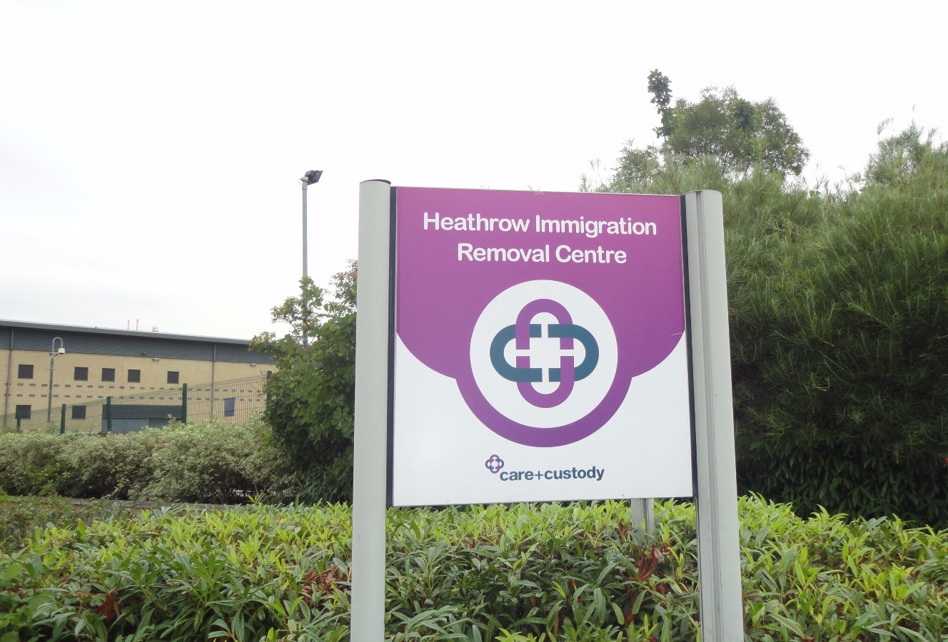
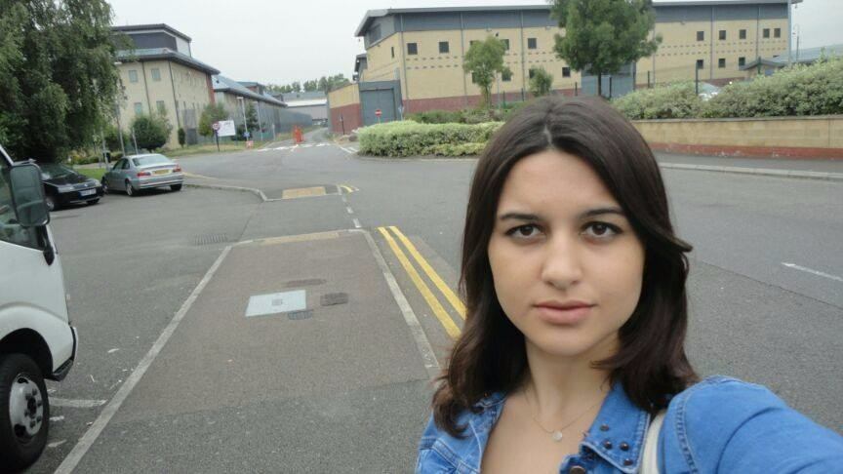
As a project coordinator, I -Beyza Ünsal- visited Harmondsworth Immigration and Removal Centre on the purpose of interview with refugees at 11 August 2015. According to www.gov.uk which is a website to find government services and informaton, visiting hours are 2pm to 9pm each day. People must bring the photo ID (a passport or driving licence) and utility bill showing name and adress. Despite my all documents were complete, the security officer said I should have name of person that I want to interview. Also he asked my visitation reason and when he learned it is for our university project he called the administrator. Administration of removal centre did not allow to me for meeting with asylum seekers. Unfortunately, interviews did not take place.
However when I was at waiting room, I met a woman by coincidence. Patricia Smith was the volunteer of Detention Action which is an association for refugees and she informed me about this organization. She said she was here for meeting with an asylum seeker that she have not known ever before. She informed me that I could take a name of person from their organization. They try to support asylum seekers at detention center. They visit asylum seekers randomly. Because Their main aim is to prevent the feeling of loneliness of people at this centre.. They inform to asylum seekers about their legal rights.
I took contact adresses of organization. Afterwards I communicated with Jerome Phelps who is the director of Detention Action. He suggested useful sources and led us for limiting our project topic. He remarked that in the UK the term ''refugees'' is only used to describe people granted status, while people still in the system are called ''asylum-seekers''. He informed that they only work with people in detention so they do not have an overall view on the treatment of refugees. According to given information by him, the key issues are destitution and quality of asylum-decisin-making. We utilised to the sources which were suggested by him during the writing of this report.
In addition, throughout the project, we researched associations' and centres' works from England such as Refugee Action, Refugee Rights, Avid Detention, Refugee Council, Detention Action, Asylum Aid, University of Oxford-Refugee Studies Centre. We communicated with chosen ones. However we could not make an appoinment. They indicated that they have no capacity to assist with student requests. This situation also shows that how these organizations have excessive work and they work hard.

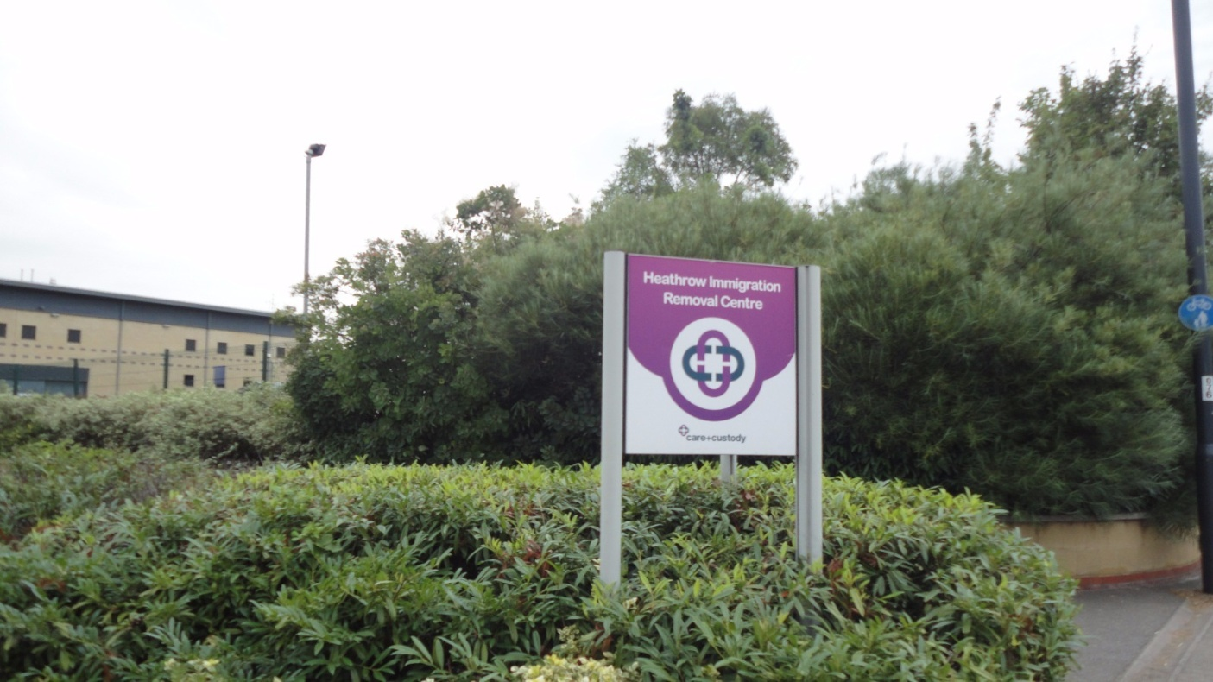

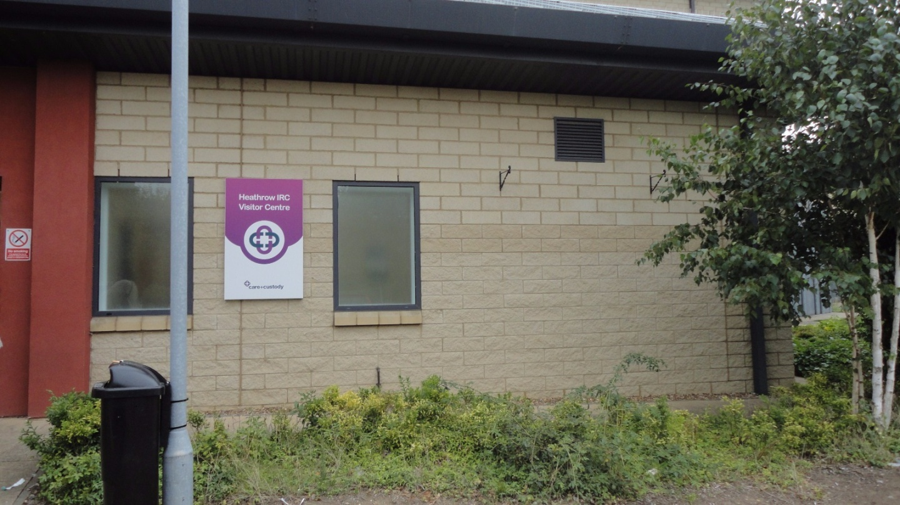

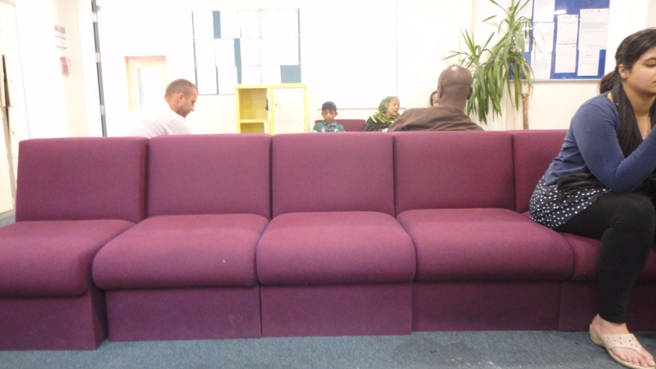

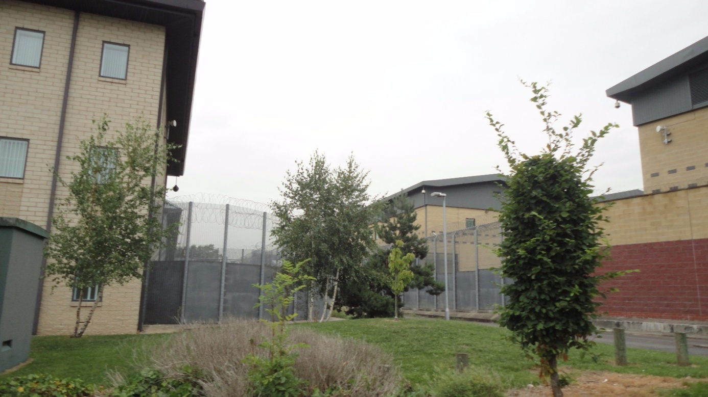
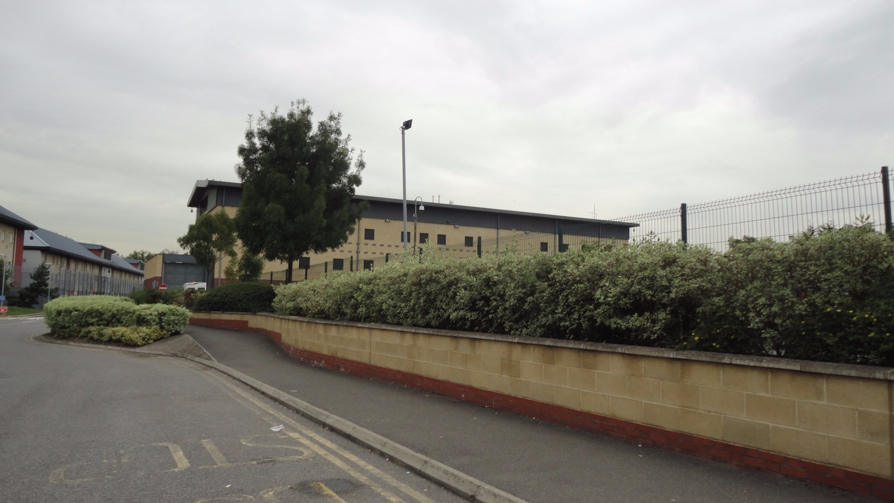

Rossano - Italy
According to the information that we reached after our research, it was not possible to make an appointment from a Centro di Identificazione ed Espulsiones located in Italy. Because of this, we decided to visit an illegal camp in Italy. What we saw in a TV report of BBC (http://www.vidivodo.com/italya-gocmen-kampi-gazeteport) became the source of inspiration to us. People who seek asylum in Rossano made a living for themselves in an old factory by working daily in nearby farms. It was stated that organizations like Doctor Without Borders were involved with the camp to provide medical services. We went to Rossano in 16 August 2015 to visit the camp at firstplace. When we asked the camp and refugees to local people in Rossano, they took us to an abandoned sport center not an old factory. What we observed at the sport center that there were mattresses, blankets and clothes inside the building, a pair of muddy boots which are signs of that there are people living in the place. However, we could not see or talk with any refugee in the sport center. What we guessed was those people had gone to work in other places or had taken to another place to reside. Later on, when we asked about this to Daniela Morales in our interview, what she told was it was a possible relocation of those refugees in Rossano to a nearby city. 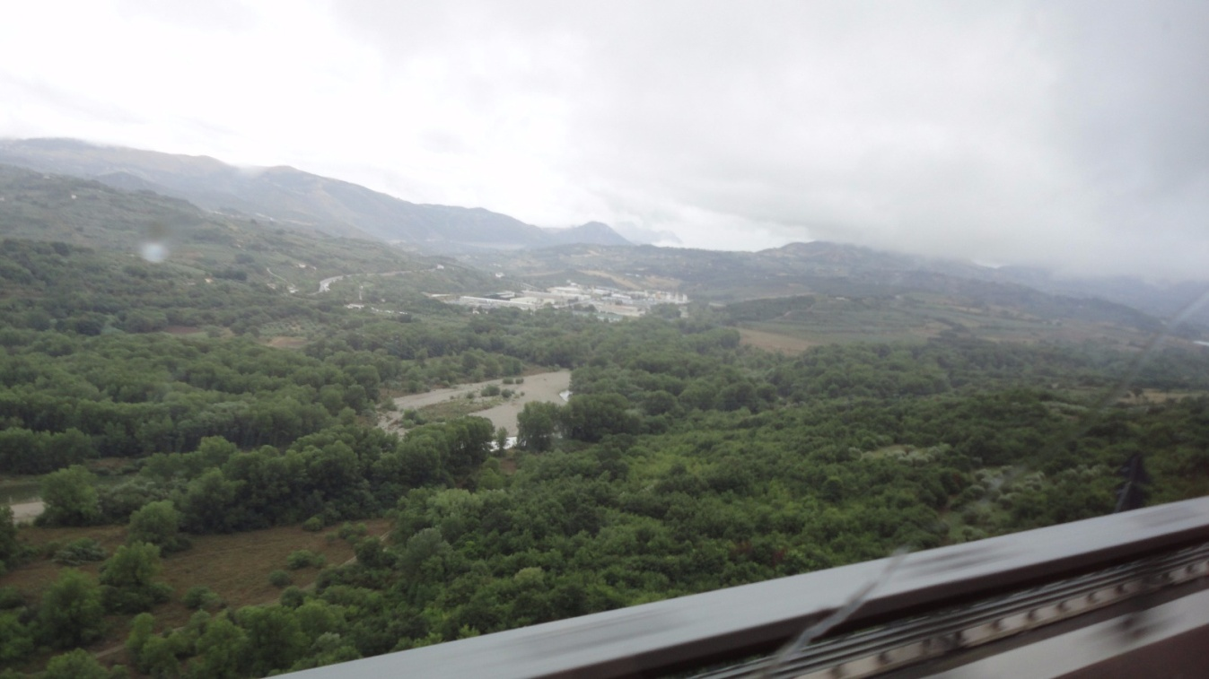 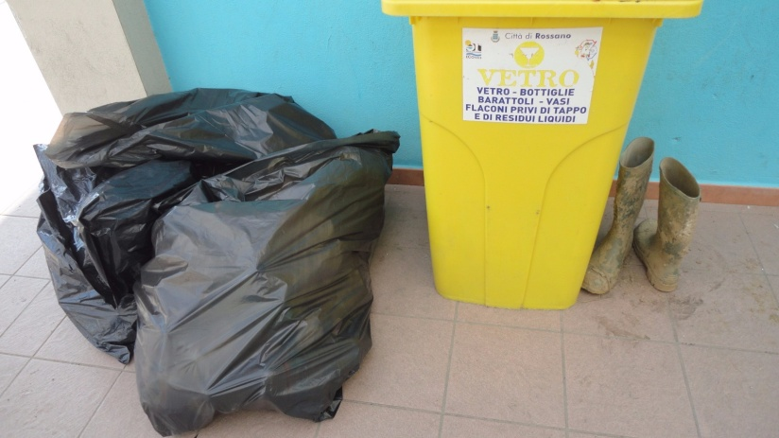
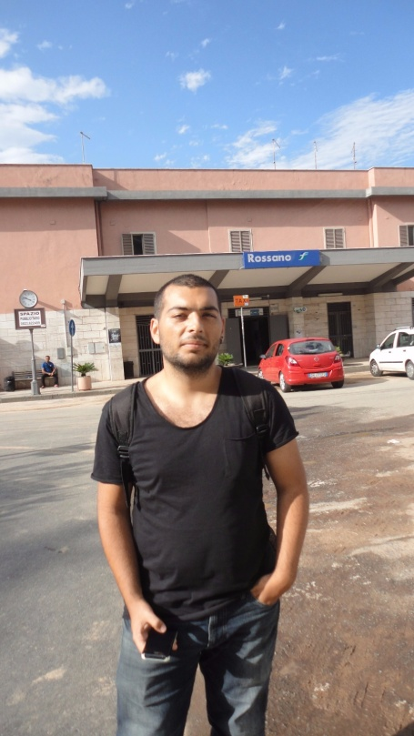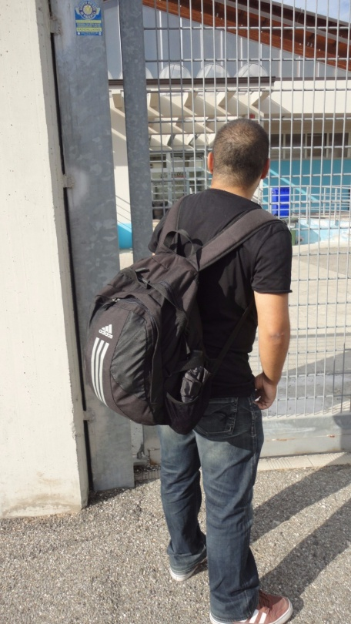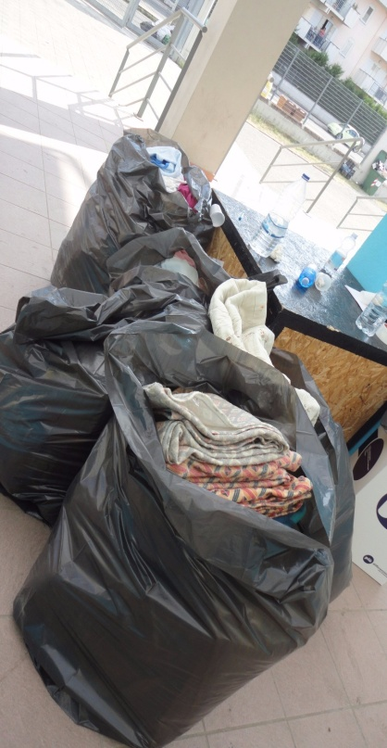
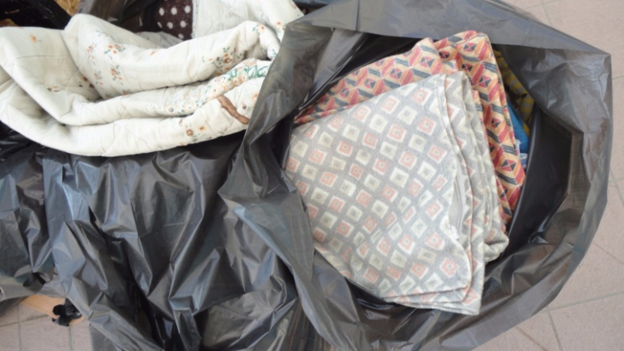

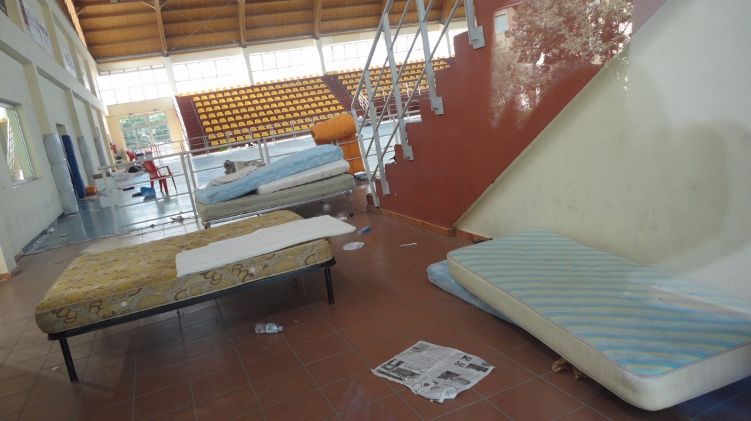

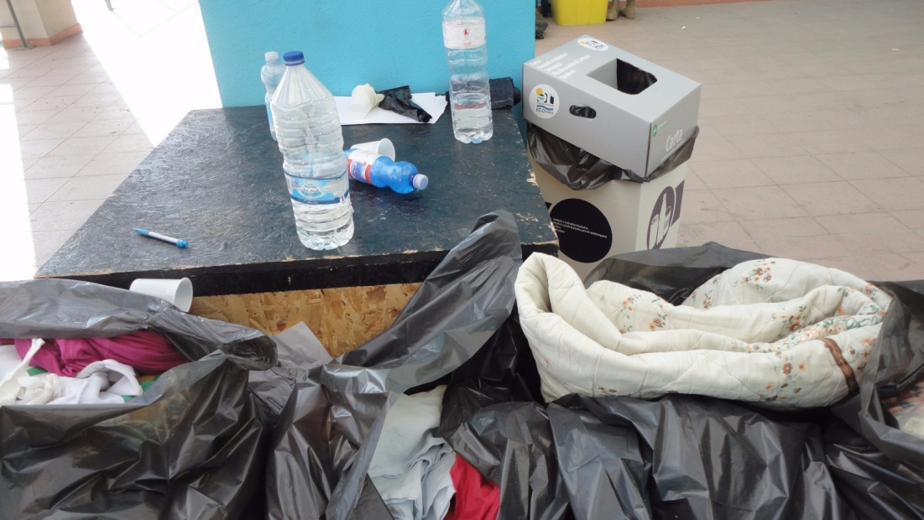
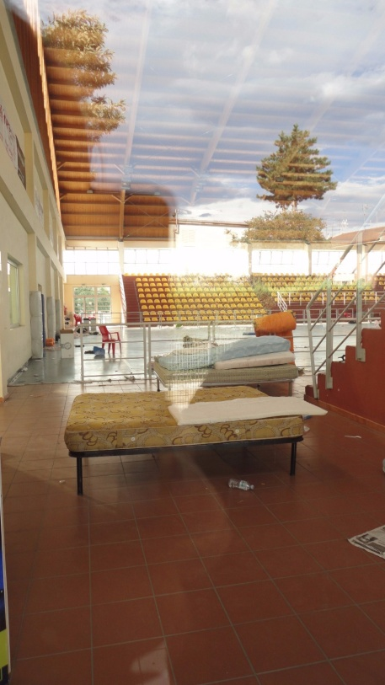
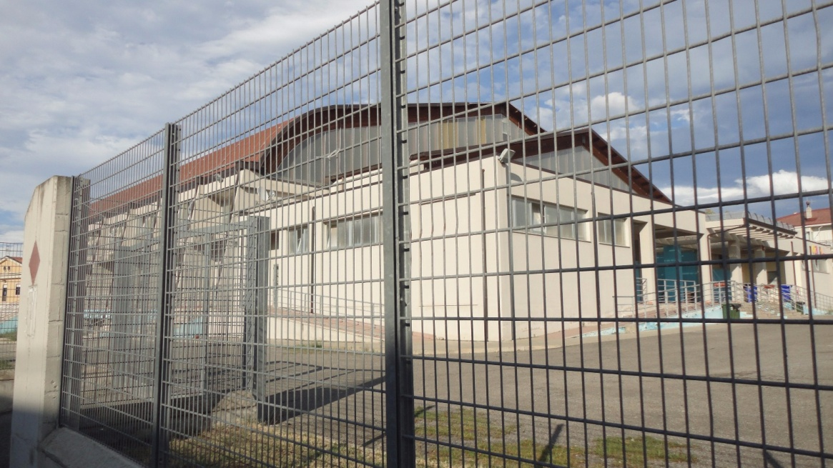
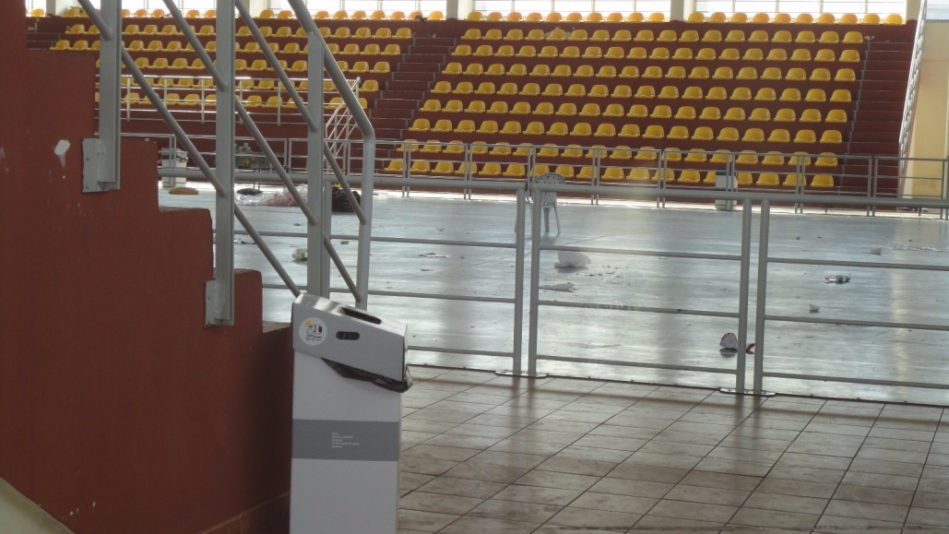
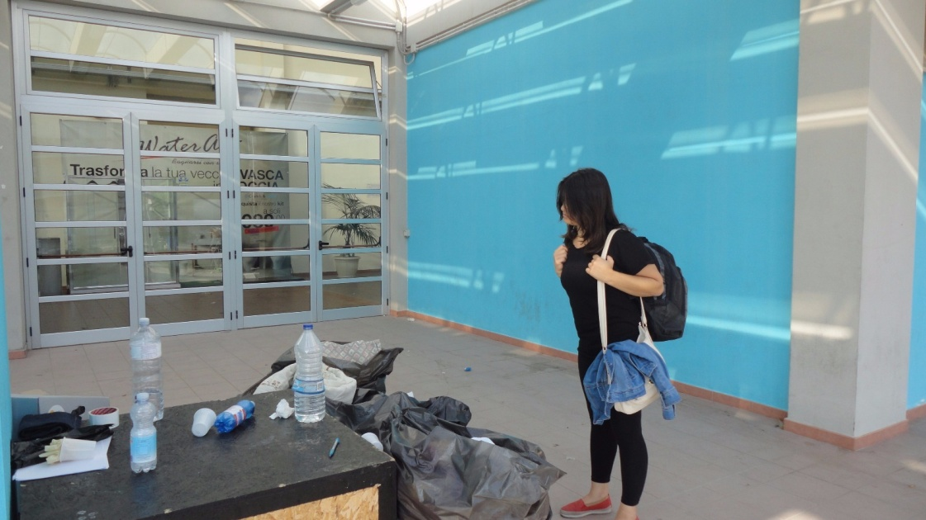
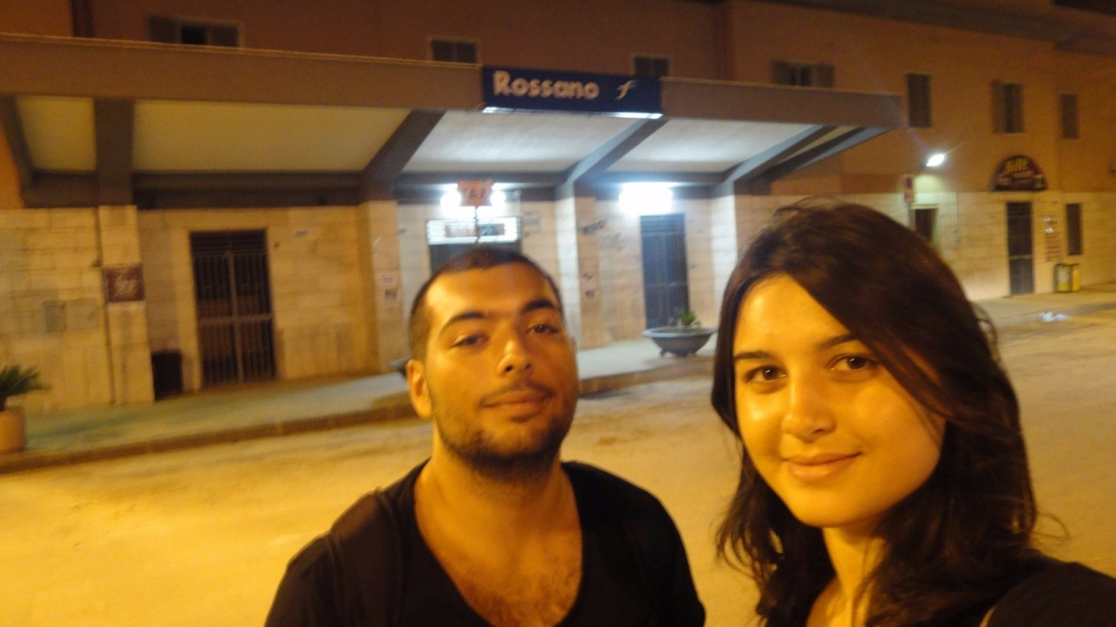

Gaziantep – Turkey
We went to Gaziantep Directorate General of Migration Management by requesting to have an interview with Oktay Bahçeci who is the administrator of the organization. He informed us about the processes of refugees in Gaziantep to have formal documents which were papers for dwelling and permission documents to leave refugee camps. After that, we also visited AFAD (Prime Ministry Disaster and Emergency Management Authority) to have information about refugee camps located in Gaziantep. We were told that applications to visit those refugee camps were being declined because of the recent manipulative news published in media. We were not able to enter the camp but we have seen that city center of Gaziantep is adapting to it’s new Syrian guests. Usage of Arabic addition to Turkish had become widespread in the city.
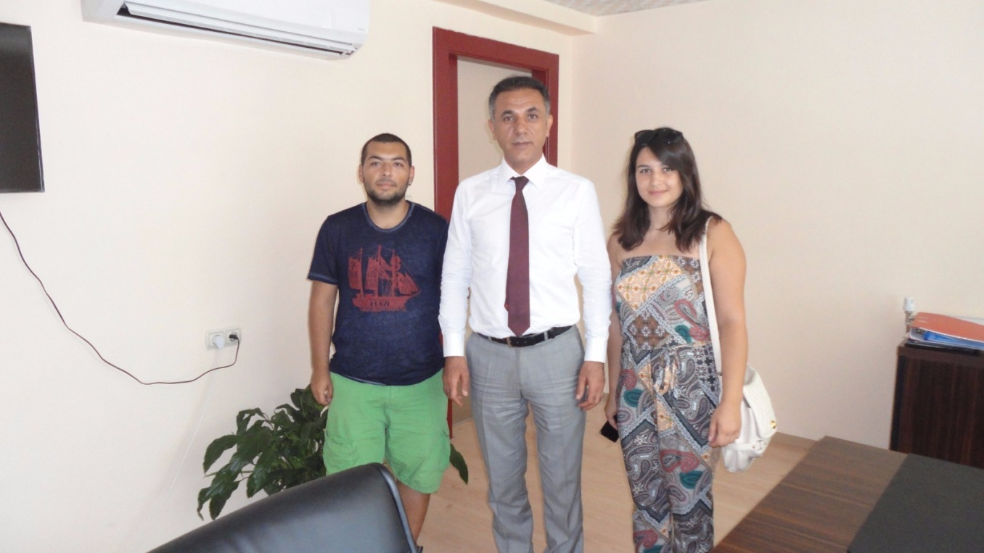

2.2- Interviews with non-governmental organization representatives were done. Those interviews provided information about different asylum policies, suggestions about solutions to refugee problems.
Interview with Daniela Morales from Joel Nafuma Refugee Center – located in Rome – helped us to understand the policies of Italian government on refugee problems. Although there are not much presence of governmental and non-governmental organizations dedicated on aiding refugees in Italy in internet, she informed us by describing many organizations in Rome and their policies. To begin with Joel Nafuma Refugee Center, center aims to satisfy and assist all needs of a person who is under refugee status. Apart from serving breakfast, providing clothing and basic items, center also helps adaptation and integration processes of guests.
To name other organizations briefly, SPRAR (Sistema di Protezione per Richiedenti Asilo e Rifugiati, Protection System for Asylum Seekers and Refugees) is an organization supported by the Italian government for monitoring the presence of asylum seekers and refugees in Italy and supporting them.
Centro Astalli is an another orgaization that have multiple centers located different cities in Italy. These centers aims to help political refugees in thir legal services, also providing doctors and pharmacy services and providing basic needs.
MEDU (Medici per i Diritti Umani, Doctors for Human Rights) is a no profit organization dedicated to bringing health assistance to people in situations of crisis and bad conditions. With this principle, MEDU also helps refugees in Rome by providing medical services.
Although there are many other organizations which are not listed above, both governmental and non-governmental, trying to assist refugees, there are also many informal organizations that are established by migrants and refugees because of the insufficiency of formal organizations. One example of those organizations is Baobab Cultural Center which is self-managed by Eritrean community in Rome. Center volunteers to help migrants and refugees by providing basic needs for them.
One of the informal organizations was Ponte Mammolo Camp where migrants and refugees from different nationalities lived together for almost two decades. Destruction of the camp by Italian government in May 2015, left many migrants and refugees homeless and caused them to lose their contents such as personal papers, clothing, money, medicines.
Interview with Daniela Morales also helped us to understand the perception of Italian society towards refugees residing it their country. According to her, many people in Italy tend to ignore to understand the difficulties that refugees faced and they are biased to generalize refugees as economic refugees without knowing the stories of refugees.
She also informed us about the Mafia Capitale scandal involving the government of the Rome in December 2014. Many politicians, businessmen and city government members of Rome (37 people as stated in The Daily Beast and Telegraph) were arrested due to exploiting refugees newly arrived in Rome also corruption, fraud, money laundering and embezzlement. Because of this scandal and the ongoing effects of this corruption until revealed, Daniela stated the impossibility of tracking the funds provided by the government to help refugees.
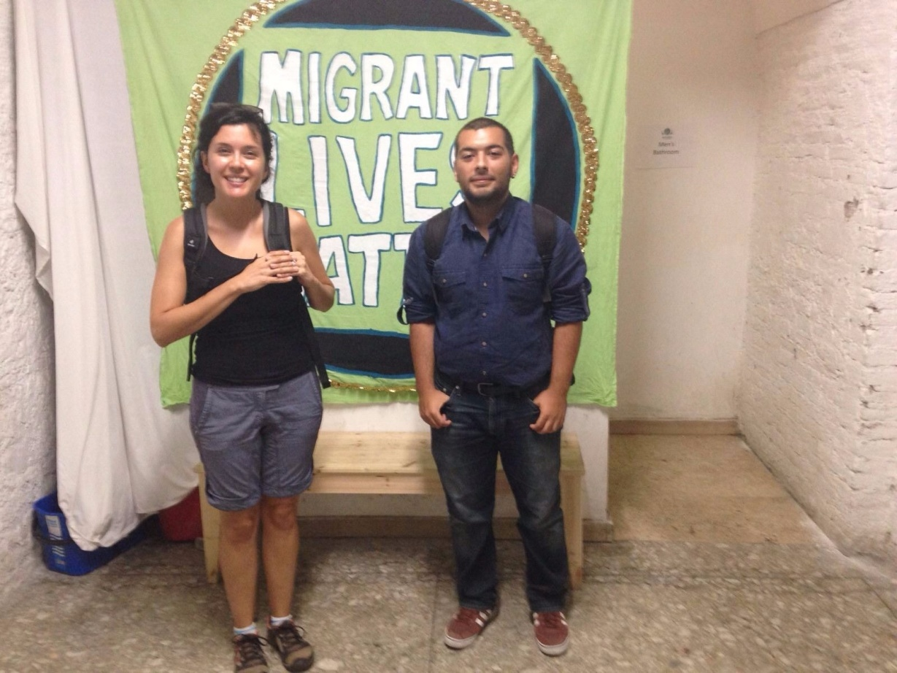
3- Conclusion
3.1- Notes that has been taken in the course of observations and interviews were evaluated and compared with each other and the preliminary research findings.
We began this project because of the fact that these problems discussed throughout this paper are Turkey’s prior issues for recent years. We supposed the situation of European countries were better than Turkey and we could find better examples of facilities provided in Europe on this field. However, as a result of this study, we can argue that there were lots of points about implementation of those facilities that European countries were lacking on.
After the news that we read before field study, we found out many examples showing that situations related to living conditions of asylum seekers were unbearable. What we can say after our project, in Europe, the process to be considered as a refugee is much harder than living as a refugee.
In our interviews with representatives of non-governmental organizations, it is often said that “Turkey is an examplatory country in terms of providing facilities for refugees, attitudes towards who are obliged to migrate also funding a very large budget to make these things happen.”. Number of the refugees are accepted in Turkey is found incomperible with the European countries. Turkey’s attitude is considered much more prudential when compared to their origin countries.
Main cause of the consideration of Turkey as a more prudential country when compared to European countries, may be the fact that in Turkey there is no definition called ‘asylum seeker’. People who would be called asylum seekers if they were in same situations in Europe are automaticly defined with refugee status. This allows Turkish policies and procedures to operate faster in terms of providing the needs of refugees.
Integration of refugees can be considered one of the most important problem that European Union countries have. In fact, instead of solving the problem, policies abour detentions are creating the problem itself. At the present time, problem is caused because people from different cultures, patterns and social bondings are forced to live together and isolated from outside world. Also, those people who are defined as ‘asylum seekers’ in Europe are facing extreme living conditions in their detention centers. With their current state, detention centers are not performing any efforts to help asylum seekers for their integration to society because centers are isolating those people from the society. There should be a new policies to distinguish prisons and detention center where innocent people forced to live not the guilty.
An interwiev based on a report of Detention Action^{[1]} is a concrete example what we put our effort to emphasis above. “When I was finally released from detention I felt lost. I felt scared. I had been isolated so long I couldn’t look people in the eye. I was so used to only ever moving a few metres this way or that, I found it difficult to walk any more than that. The Home Office had turned off my brain for three and a half years, so I had trouble reading. Even basic street or shop signs.” said by Hamid who is a former detainee.
As we stated many times in this report, thre refugee crysis that Turkey is trying to deal with it is getting more intense every day. Considering the fact that Turkey also providing work permissions to refugees, it is likely that most of the Syrian guests of Turkey will continue to reside in the country for long time. As a result of that, it can be expected that Turkish cities will have more demographical changes.
Syrian refugees brought many problems with them. One of those problems is the education of Syrian children and reintrudicing those children to society after their education. It is stated in Girit’s article^{[2]} that more that half of the Syrian refugees residing in Turkey are people with age under 18. Currently, nearly half of those Syrian children are taking education in Turkey but their education is not sufficient because of the fact that most of those children do not know Turkish. Alternative to education provided by Ministry of National Education, there are private Syria schools giving education in Turkey. Syria schools may be helping them with education in their native languages but, on the other hand, they are taking away the chance of their students to take universty education in Turkey.
If this situation continues, it is likely that both Turkey and Syria will have a missing generation of young people. It might cause undesired results. Those children may end up in joining radical groups. If they return to their origin country, they may fail to rebuild Syria because one cannot claim that Syria has a young generation to rebuild itself when armed conflicts end. Both Turkish and neighbor governments should conduct reforms in education in order to integrate Syrian children into their society and also to offer them sufficient education to rebuild Syria when the political unstability ends.
There are many changed in Turkey’s policies about refugees throughout our project. Work permission to Syrian refugees has been given while we were working on this paper. Despite the fact that, only 5% of Turkish society supports work permission for refugees, we believe that this permission was a necessity. This permission ensured that Syrian refugees will not be considered as source of cheap labor in Turkey. More important than that, with this permission qualified people will not be obliged to migrate Europe for the sake of better job opportunities. This situation contributed to integration of Syrian refugees to Turkish society. As Girit stated^{[3]}, in near future, Turkey will need qualified Syrian peoples who have influence on public opinions and capacity to establish bondings between Syrian and Turkish societies.
In this paper, we aimed to put a brief explanation about a topic which is one of the most important problems of many countries in the world. Our goal was to make reader to have a self-evaluation about this topic after being informed about both legal process and crucial decisions of important organizations and countries and the stories of those refugees which are collected from media. We want to observe the places mentioned in the news to have a better understanding about the reality and importance of the topic. It was a great chance for us to have an opportunity to visit other parts of the world and meet with people working on the same field. We believe that solutions of problems about people who are ‘refugees’, ‘asylum seekers’ or ‘migrants’ are possible. If people from non-governmental organizations are allowed more in decision making about refugee and migration problems, it is possible to reduce the problems of people who migrated there.
3.2- Representation of final report with the data collected throughout the project.

REFERENCES
Cover Image : Nizar Ali Badr
In Introduction Part
- United nations high commissioner for refugees. (2016). UNHCR. UNHCR viewpoint: 'refugee' or 'migrant' - which is right?, from http://www.unhcr.org/55df0e556.html
- -
- -
- VICE. (2013). Inside and immigrant refugee camp in italy, from http://www.vice.com/read/inside-the-lampedusa-refugee-camp
- Radikal. (2013). İtalya kadın-erkek demeden göçmenleri souyp hortumla yıkıyor!, from http://www.radikal.com.tr/dunya/italya-kadin-erkek-demeden-gocmenleri-soyup-hortumla-yikiyor-1166829/
In Progress Part
- İçduygu, A., Yükseker, D. (2010). Population, space and place. Rethinking transit migration in turkey: reality and re-presentation in the creation of migratory phenomenon. Published online in Wiley Online Library
- -
- Article based on,
Özcan, M. (2005). Avrupa birliği sığınma hukuku: ortak bir sığınma hukukunun ortaya çıkışı (pp. 11-24). Ankara: Uluslararası Stratejik Araştırmalar Kurumu
- United nations high commissioner for refugees. Convention and protocol relating to the status of refugees. Geneva: UNHCR Communications and Public Information Service
- United nations high commissioner for refugees. Convention governing the specific aspects of refugee problems in africa, from http://www.unhcr-centraleurope.org/pdf/resources/legal-documents/international-refugee-law/1969-organization-of-african-unity-convention-governing-the-specific-aspects-of-refugee-problems-in-africa.html
- United nations high commissioner for refugees. Declaración de cartagena sobre los refugiados. Geneva: UNHCR Media Relations and Public Information Service
- Article based on,
Brady, H. (?). EU migration policy: an a-z (pp. 6-7). London: Centre for European Reform
- Orhan, O. (2015). Ortadoğu stratejik araştırmalar merkezi. Effects of the syrian refugees on turkey (pp. 12-20). Published by ORSAM and TESEV, Ankara
- Ünal, S. (2014). Zeitschrift für die welt der türken. Türkiye’nin beklenmedik konukları: “öteki” bağlamında yabancı göçmen ve mülteci deneyimi (pp. 71-82).
- Relocation quotas. (2015). Retrieved March 01, 2016, from http://www.economist.com/node/21665640
- https://www.instagram.com/p/7nYqmqNmQB/
- Turkey 'acting illegally' over Syria refugees deportations - BBC News. (n.d.). Retrieved March 01, 2016, from http://www.bbc.com/news/world-europe-35135810
- A surge from the sea. (2014). Retrieved March 01, 2016, from http://www.economist.com/news/europe/21612228-illegal-migration-causing-strains-across-continent-surge-sea?fsrc=scn/tw/te/pe/ed/asurgefromthesea
- Two children drown every day on average trying to reach safety in Europe. (n.d.). Retrieved March 01, 2016, from http://www.unhcr.org/56c707d66.html
- What happens after refugees arrive in Greece. (2016). Retrieved March 01, 2016, from http://www.economist.com/news/europe/21690142-economist-visits-only-operational-hotspot-country-what-happens-after-refugees?fsrc=scn/tw/te/bl/ed/whathappensafterrefugeesarriveingreece
- -
- Entering U.S. as refugees would be hard for terrorists. (n.d.). Retrieved March 01, 2016, from http://edition.cnn.com/2015/11/20/politics/paris-attack-refugee-visa-waiver/index.html
- Will Germans embrace or shun refugees? - BBC News. (n.d.). Retrieved March 01, 2016, from http://www.bbc.com/news/world-europe-35062438
- Crossings of Mediterranean Sea exceed 300,000, including 200,000 to Greece. (n.d.). Retrieved March 01, 2016, from http://www.unhcr.org/55e06a5b6.html
- Republicans to President Barack Obama: Keep Syrian refugees out. (n.d.). Retrieved March 01, 2016, from http://edition.cnn.com/2015/11/16/politics/republicans-syrian-refugees-2016-elections-obama/index.html
- Syrian refugees: States cannot refuse, but they can make it difficult. (n.d.). Retrieved March 01, 2016, from http://edition.cnn.com/2015/11/16/politics/refugee-states-governors-syria/index.html
- Almost home. (2015). Retrieved March 01, 2016, from http://www.economist.com/news/china/21672335-china-has-successfully-absorbed-many-refugees-vietnam-it-ill-prepared-another?fsrc=scn/tw/te/pe/ed/almosthome
- Budapest migrant stand-off enters second night - BBC News. (n.d.). Retrieved March 01, 2016, from http://www.bbc.com/news/world-europe-34128263?ns_mchannel=social
- The future of migrants and refugees. (2015). Retrieved March 01, 2016, from http://pulitzercenter.org/reporting/europe-italy-migration-refugees-politics-olympic-village-turin-sharp-seminar
- Riots close Italy's immigrant detention centers. (2013). Retrieved March 01, 2016, from https://strugglesinitaly.wordpress.com/2013/09/04/en-riots-close-italys-immigrant-detention-centers
- İngiltere’den...mülteci kamplarında insanlk dışı uygulama. (2006). Retrieved March 01, 2016, from http://www.suvedefne.com/yazarlar/ali-keskin/2006/12/14/ingiltere-den-multeci-kamplarinda-insanlik-disi-uygulama.htm?aid=1585
- İtalya’da mülteci kampları ve mülteci isyanları. (2015). Retrieved March 01, 2016, from http://sosyalsavas.org/2015/02/italyada-multeci-kamplari-ve-multeci-isyanlari/
In Field Study Part
- References in the article Harmondsworth
- Increasing number of asylum detainees freed after near-fatal hunger strikes. (2013). Retrieved March 01, 2016 from http://www.theguardian.com/uk/2013/jun/14/asylum-detainees-hunger-strikes
- Videos about Harmondsworth Immigration Removal Centre (2015, 2014). Retrieved March 01, 2016 from http://www.standoffilms.com/#!videos/cee5
- Harmondsworth undercover: ’I don’t want to die here’. (2015). Retrieved March 01, 2016 from http://www.channel4.com/news/harmondsworth-immigration-detention-centre-undercover-video
- Immigration centre firms face £10.000 fine if detainee dies from self harm. (2015). Retrieved March 01, 2016 from http://www.theguardian.com/uk-news/2015/dec/03/immigration-centre-firms-10000-fine-detainee-dies-self-harm

In Conclusion Part
- http://detentionaction.org.uk/wordpress/wp-content/uploads/2014/10/The.State_.of_.Detention.pdf
- Suriyeli mülteciler dosyası: eğitimde kayıp nesil riski. (2015). Retrieved March 01, 2016 from http://www.bbc.com/turkce/haberler/2015/10/151006_suriye_selin
- Suriyeli mülteciler dosyası: İstihdamda 'en alttakiler' - BBC Türkçe. (n.d.). Retrieved March 01, 2016, from http://www.bbc.com/turkce/haberler/2015/10/151007_suriyeliler?ocid=socialflow_twitter

