ÖZGÜR PROJE 2016
Animals: Are They Ours to Eat?
Project Team Members: Öykü Teoman, Ece Yegane

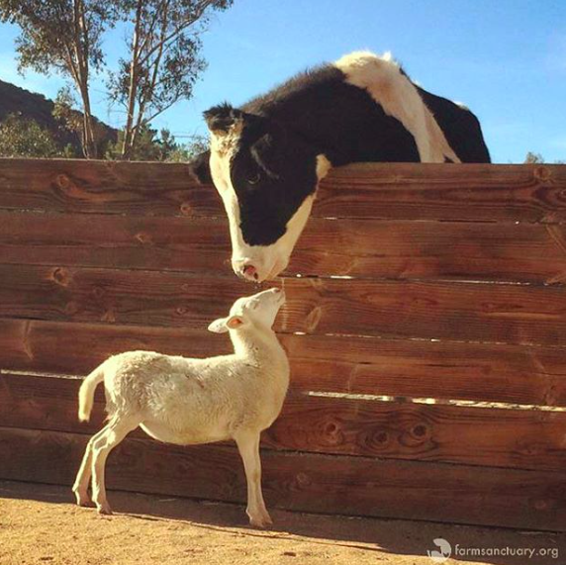

“For most human beings, especially those in modern urban and suburban communities, the most direct form of contact with non-human animals is at meal time: we eat them. This simple fact is the key to our attitudes to other animals, and also the key to what each one of us can do about changing these attitudes.”
-Animal Liberation, Peter Singer

Why do we eat cows when we are feeding dogs? How do we decide eating some animals is normal while eating the rest is barbaric? Our project’s aim is to analyze and inquire the situation of animal rights in Turkey and to what extend the Turkish cuisine is based on animal products. If there is such a dependency on meat, dairy and other animal products in traditional Turkish food, can this explain the unpopularity of vegetarianism and veganism in Turkey? Does this lack of demand further make the transition into vegetarianism and veganism harder and more unlikely? How does Turkey stand in comparison to EU countries?

Method and Execution Plan
-To analyze the place and importance of animal products in Turkish cuisine starting from Ottoman period
-To analyze the current state of animal rights in Turkey
-Interviews with international and Turkish animal rights organizations, vegetarian and vegan societies (PETA, Farm Sanctuary, TVD, HAYTAP)
-To understand the scope of academic literature regarding this topic, particularly in Turkey
-To attend the International Animal Rights Conference in Luxembourg (for more information: http://www.ar-conference.com)
-To create a cruelty-free area on campus
Encouraging campus cafes and the cafeteria to provide more vegetarian and vegan options
Assuring safety and well-being of campus animals
To put out a cruelty-free festival on campus with the participation of cruelty-free brands and vegetarian/vegan food stands (we will seek for additional sponsorship besides the Özgür Proje budget)
-To prepare a comprehensive vegetarian/vegan lifestyle guide that is available to everyone
-To create an Instagram account, which posts regular updates on the progress of the project and vegetarian/vegan lifestyle tips

International Animal Rights Conference
Overview of the speakers
Simon Anhut (Germany), animal rights activist with the German groups Venga, which he co-founded, and Animal Rights Watch (ARIWA)
Johnny Braz (United States) together with Indra Lahiri runs Pennsylvania`s only nonprofit farm and all species animal sanctuary, while sharing the animals` stories through writing, film, and photographs
Stijn Bruers (Belgium) PhD in physics and philosophy & moral science, activist of Bite Back, author of books about environmental ethics and animal rights
Beata Ciupinska (United Kingdom), animal rights advocate, an organizer of Awakening Compassion demos in London
Liz Tyson (United Kingdom), international director of the Palestinian Animal League and founding member of the Palestinian Animal League Solidarity

Workshops
How to talk effectively with meat eaters
WORKSHOP Martin Smedjeback
How to start a save group in your area and why it is important to bear witness
WORKSHOP Andrew Garner
Sanctuary yoga: Giving animals a good death & how we learn about ourselves
PRESENTATION Johnny Braz
Big picture strategy for an animal-free food system.
DISCUSSION Jacy Reese
Civil disobedience for the animals
PRESENTATION Martin Smedjeback

