Running Head: A generalized Stress Study

A generalized Stress Study
An Ozgur Project Initiative
M.M.Hussain, M.Ammar, I.S.Rizvi, R. Virani
Sabanci University

An Ozgur Project Initiative: Understanding stress in an academic environment

Abstract―This paper seeks to establish a generalized overview of Stress in academic institutions, namely: Sabanci University. The study, which is a generalized study is seeking the confirmation of several hypothesis under the abovementioned subject matter; a) does stress experience differ from student to student based on their academic and nationality level, b) is there a positive correlation between academic level and stress experience, c) do bad employment of coping strategies lead to an increase in stress level and lastly a few general questions as to whether the students find the campus life as a suitable environment, and would they feel comfortable with the idea of receiving professional help for their stress problems or not. These hypothesis are formulated as multiple choice questions in survey form, and are therefore the IV of the study, where the DVs are the rating the students provide for the questions. Therefore, this paper has three aims: to present a reason for carrying a generalized stress study, to discuss the literature available for the topic and, to discuss the abovementioned study conducted by the researchers themselves, so as to offer a result that could help conclude the applications of the study altogether.
INTRODUCTION TO STRESS
Stress has been known to affect people in academic institutions, more specifically: students in varying degrees of intensity (Sax, 1997), and therefore several studies carried in order to investigate the problems associated with it, along with finding means of solving the problems have been carried over time. While the literature is overwhelming, for the purposes of this paper; I will mention only a few major studies that have been done into the topic itself. A main point to keep in mind is that Stress can take innumerable forms, and when it comes to academic institutions; one can explain stress to be present as academic stress and generalized stress respectively. The literature identifies academic stress as being related with academic activities that the student is unable to perform during to certain limitations that the employment of activities puts on him/her. According to Abouserie (1994), Archer and Lamnin (1985); Britton and Tesser( 1991); Kohn and Frazer (1986), academic stress comes from giving and preparing for exams, competition for better grades and the prospect of memorizing a large amount of course-related matter in a few days. The three partite explains helps sum up the causes of academic stress nicely, however, it could be suggested that these are but a few causes that could be held accountable for leading to academic stress. Therefore, as researchers, we will explain that there are but several variables that make a student feel stressful in an academic environment, such as perhaps bad campus life, inability to perform in classes, employment of bad coping strategies, etc. But, the study itself is a matter of discussion for a later heading.
A valuable result from an earlier study by Murphy and Archer (1996) suggested that stress is the effect of students’ negative perception of the working of their academic institutions which in turn causes stress in the form of either a physical or psychological impairment. This helps establish the general idea that stress can be categorized as an imagined effect for the students too. It can be agreed, however, that this is but one side to the debate and one could argue that stress is caused by other variables (for e.g. hard courses, bad campus life, etc) too.
Another view that goes hand-in-hand with that of Murphy and Archer (1996) is that of Entswille and Ramaden (1983); Kirshenbaum and Perri, (1982) as an addition to their argument is that students who study proficiently, manage their time productively for various academic tasks are less affected by academic stress altogether. However, again this generalization fails to consider the possibility that productive students may be experiencing stress from other sources, such as their demanding family or teachers and from their harsh environment. Therefore, it provides a reason to study stress in all academic institutions possible, so as to confirm whether such generalizations can indeed be applied to every one of them. It is also under this necessity that the researchers decided to conduct a study in Sabanci University as well. Furthermore, the idea that time management is an excellent coping strategy is widely supported by literature, but again it is important to emphasize that there still exists the possibility of students being able to manage time, but not being able to reduce their stress in the process. As an additional question, which the researchers of this paper therefore decided to check was whether perhaps wrong use of coping strategies induces stress too, since the possibility of students being unable to handle their stress is very much a tentative to further investigate upon. Nevertheless, the generalization that time management leads to a reduction of stress is still a good generalization, even if it can be validated by other studies. This is because there are several students who have a problem managing their time when it comes to attending their classes, or handing in assignments in Sabanci University, which in turn places their grades in jeopardy and therefore can be considered as an important variable for inducing stress into them.
In all the stress-related literature, it is important to understand that there are various categories of social groups that these studies check difference in stress experience, since another assumption that many investigators make is that the experience is governed by the type of ethnic or gender class a student may belong to. To illustrate this assumption; the general argument is that Asian students are more stressed than European students, because of familial pressure on them for getting good grades whereas parents seldom pressure students in Europe. The British Council released a report two years ago which conducted an investigation and managed to find that Asian students did indeed have better scores than European children in O and A levels held by the Cambridge Board of Examination respectively.
While this assumption hints at having a stereotypical views, it is nevertheless important to keep in mind that class differences and gender have been a basis for several important stress-related studies. In the next section Review of Literature, the researchers of this paper will give two main examples of such studies and therefore explain as to why they too believe that testing stress level and experience in terms of this category is significant too. This does not, however, imply that the study is basing itself on stereotypical view or believes in stereotypes for that matter, but believes it necessary to test under this category so as to see if the stereotypes indeed exist or not. If they do exist, then the researchers’ aim after the results will be to explain as to why they do.
Furthermore, another category that is vital to discuss in the next sub-section is the procedures and methods involved in the assessment of stress in earlier studies. This is because the researchers of this study believe that there are certain procedures that are more reliable than others, and a different procedure can risk giving a different result altogether. This does not imply that the earlier studies were poor at controlling their experiment, but it is an extensive debate in the discipline regarding as to which procedure is suited for which study. To a psychologist-in-training, there are two ways of classifying methods; Experimental and Non-Experimental namely. And if one uses generalized surveys, interviews, natural observations, etc, these measures are classified as non-experiment and while they might give results high in ecological validity, the lack of control of variables would lead to a result containing the effect of extraneous variables and would therefore be deemed as unreliable. Similarly, while experimental measures may give reliable results due to effective control, they will however be low in ecological validity and several issues such as taking a less-representative sample could make it unreliable in terms of making generalizations too. So, it should be therefore kept in mind that both means have their related problems and one can never be completely sure that the result provided through them is genuine. However, if they provide good generalizations then it is good enough. Because the researchers of this paper are undergraduate students, the procedures they will use as a preliminary stage of the study will be non-experimental, but nevertheless standardized as much as possible. The reasons for this will be explained in a later sub-section.
Therefore, procedures matter when it comes to conducting studies and when reviewing literature, it will be pointed out far extensively as to the reasons behind that argument.

REVIEW OF LITERATURE:
There was a series of case studies that were undertaken in a project entitled as Improving Provisions for Disabled Psychology Students (or IPDP for short). While the participants were special needs psychology students and the studies were an attempt to figure out the various ways they try to cope with academic stress. This was the aim, as it would help the investigators come up with suggestions for improving their academic lives as a whole. Though the sample was not representative, since it contained only students diagnosed with certain kinds of disorder; there were some aspects of the procedure involved which is worth discussing here. The aspects that are in the researchers of this paper are the research questions that the study tried answering as a means of carrying an extensive survey into the students’ lives (check the Questions they asked in Appendix A). From basic questions such as ‘what are the causes of stress?’ to structural questions such as ‘how do these stressors affect the student’s self-esteem?’ were investigated upon.
Since the researchers of this paper have similar questions; the main ones being as to what causes stress in students of Sabanci university and whether it has a negative effect on them; it is crucial to understand that these questions would be ideal to include in a stress-related questionnaire, which was the researchers’ stage for the particular study. These questions, if asked in an appropriate manner and by a large sample could on a preliminary level help create a basic idea or ideas as to how the stress experience of Sabanci is like and furthermore, how the knowledge can be applied to improve the situation in it.
A recent stress-study which identified a need for changing a stressful academic environment into a friendlier one was conducted in Queens University (2012), and it helped to the creation of a report that included around 116 recommendations provided by the students to have the methods employed in course teaching and making the timetable changed. The reason as to why this study took place was because in between 2010-2011, six students in the university had committed suicide. While suicide is an extreme effect of stress, it is nevertheless necessary to understand that in academic universities such as Sabanci University which have challenging courses; the possibility can exist for all such universities and therefore, it is important all the more to investigate whether the students are stressed or not and also as to why they are stressed, so as to help come up with innovative solutions to make life a bit more livelier in such a demanding institution.
Moving towards a more structural review of literature; the researchers of this paper had identified in the earlier sub-section that gender and class differences and procedures and methods were an area of interest with regards to their own study and they would provide literature that shows the significance of study these aforementioned categories.
Misra and Mckean (2006) conducted a study that aimed at finding relationships between academic stress, time management and leisure satisfaction respectively. The study was quite extensively done, however for the purposes of this paper, it is the results that are to be considered here. One of the study’s findings suggested that female students suffer higher anxiety in comparison to male students. This, in turn led them to conclude that females experience higher academic stress in comparison to males. This is indeed a very bold suggestion, but nevertheless proves that gender comparison with regards to this topic has always been given priority even in recent studies such as this mentioned one. Other findings of the study were that though females could effectively manage their time, the males managed to reduce their stress levels by engaging in activities that provided them leisure, such as playing football for example. This suggested that leisure activities are a better suggestion than time management techniques when it came to coping with academic stress in general.
This finding inspired the researchers of this paper to consider putting leisure activities as a choice in one of the stress-related survey they carried for the study (see Appendix B). Nevertheless, while the study was quite impressive, it had its limitations and the Misra and Mckean (2006) pointed them out in the paper they wrote for it as well. They explained that the reason as to why the study could not be used for generalizations was because the sample had been pre-dominantly white (91%) and because there had been more female participants (76%); these disproportions in the selected sample lead to the conclusion that the study should have included a much more representative sample which could have ensured the generalizations of the study to be more reliable than they were.
An earlier study by Dipboye and Phillips (1990) had also tried at seeking out a correlation between time management and academic stress. Since understanding procedures concerning stress-related studies is important, it is important here to mention the methods that were employed by them for their study. They created a series of questionnaires by consulting various time-management books; hence creating a scale they titled as the Time Management Behavioral Scale (or TMB) which was to check the abovementioned correlation through questionnaires.
The sample for their study was quite representative since it had various ethnic groups to make it much more reliable when it came to making generalizations from their result. The result was that they found out that women were better at using time-management techniques in comparison to men when it came to reducing academic stress as a whole.
However, the sample sizes for the ethnic participants were not exact, since for example; the study had 12 Black participants in comparison to the 116 White ones. Dipboye and Phillips (1990) themselves noted this problem and stated in their conclusion that further studies regarding the matter needed to be replicated in order to come up with a stress-study that could make effective generalizations for the matter.
The researchers of this paper were intrigued by the point that Dipboye and Philips (1990) used a scale for measuring academic stress, and that is why they decided to use scales for their survey as well. The researchers, upon suggestion of a professor of psychology decided to use the Likert Scales for their survey.
The reasons for using the Likert Scale are several, but the main ones are that just as Likert (1992) wished; the Likert scale was to attempt at tapping into the affective and cognitive components of attitude. It did so by providing general statements, which included a wide choice of attitudes for the participants to choose from with regards to the effect the statement had on them. A good illustration of the Likert scale had been provided by Saul McLeod (2008) as follows:
Strongly Agree | Agree | Don’t Know | Disagree | Strongly Disagree

As it is obvious; the degree of choice it gives the participant is quite good, since it helps shed light for the researcher to know the attitude as correctly as possible for a certain generalized statement or question.
Having established the needs of having standardized procedures; it should also be kept in mind that the reason as to why the researchers of the Ozgur study have taken gender differences as a category to check in relation to academic stress is to see whether they will receive the same results as the abovementioned case studies did.

PROCEDURE AND RESULTS OF THE STUDY:
The study’s IV was the stress-related questionnaire and the DV was the way in which the participants responded to the questions. It was decided that the questionnaire would be distributed for three days near the university cafeteria in order to get as diverse a sample as possible. The questionnaire was timed to take approx. 10-15 minutes and due to the huge time frame for the study; it was decided that snacks would be presented as an incentive for the participants to fill in the questionnaire. Furthermore, as a reassurance that their results would not be disclosed in a specific manner which could cause them psychological distress; a consent form was also created in order to put them at ease (check consent form in Appendix C).
The plan was to have as big a sample as possible of approx. 150 students, so as to ensure that the questionnaire could be made to use good generalizations for the purposes of the study. However, as will be mentioned in the next paragraph, problems arose and therefore the results of the study though admirable and interesting cannot be used to make good generalizations altogether. Since no control could be established for having the desired number or type of participants required for the experiment; this is therefore a non-experimental study since it relies solely on questionnaires filled up by a random sample. Still, having a random sample and taking the questionnaire inside the university could ensure a degree of ecological validity for the study itself.
The various problems that were encountered by the researchers were: a) it was a snow day, so not many students were available for questionnaires; b) it was an exam week, so not many were willing to spend time giving a questionnaire and c) International Students mainly contained Pakistanis doing engineering and Erasmus group had mainly Europeans, so the sample couldn’t have been more representative as a whole.
Still, the study was not completely a failure since there were several interesting observations that could be made, such as the opinion the students had concerning the questionnaire and how having delicious sweets ensured at least a 100 participants to fill the questionnaire, despite the size of target groups (i.e. Turkish, IS and Erasmus) being quite disproportionate when considered altogether.
The results for the study are mainly provided as scores obtained through the usage of Likert Scales in the questionnaire, and therefore there is a still need to record data more comprehensively using the statistical research program (SPSS); however for the purposes of this paper, the scores will help give an idea as to how far the hypotheses made by the researchers were disproved or not. And therefore, it is necessary to divide the results in terms of these smaller hypotheses that fall under the generalized stress subject in question:
- Results for H1 and H2 (H1: there is a positive correlation between stress and academic levels and H2: female group should be more stressed than male group):
Just as an order of preference; we feel it necessary to show H2’s results instead of H1. The table below presents the female and male groups’ stress score:

Nationality | Male | Female
Turkish | 30.47 | 35.42
International Students | 32.08 | 35.14
Erasmus | 35 | 31.5

For the purposes of this study, we decided to look at Male and Female groups’ stress scores independently instead of just taking their aggregate scores in mind. It is interesting to note that the Erasmus group has males with a higher stress score than the females, since in the literature the studies had contained mainly European students and they had conformed to the hypothesis that females are more stressed than males. The reason as to why it did not conform to the predicted social pattern is because the sample was relatively small (only 8 Erasmus students), so therefore the sample cannot be used to make effective generalizations and to validate the hypothesis. However, because the sample size was relatively greater for the Turkish (17 M and 12 F) and International Students (14 F and 25 M), it is still not as great a sample as had been hoped for. Also, the number of female and male participants for both groups is not equal, hence making the results unreliable when it came to making generalizations.
Nevertheless, it at least helps conclude the prediction that had been explained in literature about women having higher stress scores than men. The matter as to why they exist is a matter for a study strictly dealing with the topic gender and stereotypes, so it will not be further elaborated here. Still, the fact that it stays true even for this study is something to keep in mind.
Furthermore, notice that the stress score for International Students is higher than that of other groups. A general conclusion that we think can explain the results in the table is that since these students are not well-versed in Turkish and feel a bit stressed due to living away from their country, they experience greater stress in comparison. However, a thing to keep in mind is that English is spoken in the University and there are several other International Students to keep company, so the conclusion is not as sound as it looks. The significance of this result, however, is that it can be used to make innumerable predictions as to why the case is as it seems. An attempt to re-check this result would be to administer our questionnaire or a better one repeatedly, so as to check if it remains the same over the years.
Having confirmed H1, we can move to H2 which suggests that there should be a positive correlation between academic levels and stress experience. That is to say, the higher you go in your degree program, the greater the stress experience will be, since the general assumption is that courses grow harder and difficult to cope with as you pass on to the next academic level. The results of H2 were as follows:
 | Male  Turkish | Female  Turkish | Male  IS | Female  IS | Male  Erasmus | Female  Erasmus
Academic Level
FDY | 24 | 41 | n.g | n.g | n.g | 33.25
Freshmen | 35.25 | 38.5 | 32 | 34.14 | n.g | n.g
Sophomore | 32.5 | 33.5 | 38.4 | 47 | n.g | 28
Junior | 34.33 | Not given | 27 | 25 | 29 | 26
Senior | 24 | 32.5 | n.g | n.g | 47 | n.g
Masters | n.g | N.g | 31.43 | 28 | n.g | n.g
PhD | n.g | N.g | 45 | 35 | n.g | n.g

If one considers the stress levels as a total, it would seem that H1 has been falsified since there is no proper correlation between stress experience and academic levels. However, if one looks at each group separately; the Turkish female and male group has mainly a negative correlation (as academic level increases, stress score decreases), The International Students group have mainly a negative correlation too, but the Erasmus group doesn’t follow any fixed pattern and so a correlation cannot be linked to it. Again, for the purposes of the paper, because the sample size of the Erasmus group, we won’t discuss its result and focus on the other two groups.
Before discussing the results, it is important to understand that there are limitations in the data provided. This is because of applying a non-experimental method which allows minimum or no control of the sample for participants. There is missing information in the table, because we could not find participants belonging to all the academic levels in the university. The reasons for this problem have been discussed in the first paragraph of this sub-section in detail.
Nevertheless, as researchers we believe that there are several conclusions that can still be made with regards to this information. The first conclusion to make is that individual differences are in play, since it depends from person to person as to whether they feel comfortable the higher their academic level goes. Secondly, however, since mainly there is a negative correlation for both International Students as well as Turkish ones, we can assume that after the first two main years (i.e. freshman and sophomore); they grow adjusted to the environment and their stress level therefore decreases. On a note of difference, the sophomores of International Students have the highest stress scores in comparison to the other groups. The researchers believe that the result turned out like this because the International Students we picked were mainly engineering students. Since the general assumption is that engineering courses are harder than other courses; that could hence explain as to why their stress scores are relatively high. Also, another thing to note is that the Turkish freshmen have a relatively higher stress score than International Students’ freshmen. This could be perhaps due to the problem of speaking English since the courses require English and fluency is gained only after passing these two years.
To conclude, the sample is too small and there is too much missing information to use the results for generalization. A retest of the study therefore is required.
- Results for H3: Does excessive use of bad coping strategies indicate higher stress levels?
As had been discussed in the Review of Literature section, it was important to see if students were using coping strategies properly or not. The question that checked for this had been provided in the questionnaire (*check Appendix B).
Since the assumption was that bad coping strategies should indicate higher stress levels; that would assume a positive correlation between excessive use of these strategies and high stress levels. In order to evaluate results for H3, we decided to take students who had high stress levels from the data and see if they were indeed using bad coping strategies excessively. It should be kept in mind that when we say bad coping strategies, we assume that an excess of any activity is bad. This means that if the student is browsing the internet more frequently than required, he/she is putting themselves into a stressful position. It also indicates that they are not using the coping strategy properly.
So, with the select information for only high stress score participants, this is the result we got:
Participant | Sex | Stress score | No of strategies used (in excess)
A | Male | 45 | 12
B | Male | 47 | 3,12
C | Male | 48 | 7
D | Male | 47 | 1-5, 12
E | Male | 57 | 1,4,5,8,5
F | Male | 42 | 1-3, 6-7
G | Male | 42 | 2,5,7,12
H | Male | 42 | Doesn’t fit with pattern! (D.n.e)
I | Male | 45 | 2,3,5,7,8,12
J | Female | 42 | 4,5,7,11
K | Female | 46 | D.n.e
L | Female | 48 | 7
M | Female | 44 | 7,5,13
N | Female | 46 | 4,5,7,12
O | Female | 41 | 3,4,11
P | Female | 45 | D.n.e
Q | Female | 44 | 6,7,11,12
R | Female | 41 | D.n.e
S | Female | 41 | 7

Out of the sample we chose which has only participants with a high stress score; it would seem that their stress level has a positive correlation with the excessive use of coping strategies according to the table. Notice that the most occurring coping strategy for these people is either listening to too much music, or spending too much time browsing on the internet. These activities, if consumed in an appropriate amount are not harmful, but an excess of anything can be bad.
There are also three participants who do not show a positive correlation with the set variables, and therefore they are the anomalies in the result. Again, it is important to point out that the sample size isn’t large enough to allow for effective generalization of the findings for the experiment. Nevertheless, one thing is for certain; the students who do things in excess (listening to music or browsing internet, or even getting drunk as some of the participants have ticked); they should learn to gain equilibrium in their lives without doing activities that may jeopardize their academic life.
Therefore, the result confirms H3. Still, because the sample size is too small to generalize, yet again we believe it important to suggest that the study should be conducted again and try to include a greater sample size for better results.

SUGGESTIONS AND CONCLUSION
In the end, there are a few general statements that we also decided to measure as a means of offering suggestions for Sabanci University, so that these suggestions may prove useful if the authorities feel that a need to change the environment and make it more user-friendly is in order.
Firstly, let us make it clear that despite the limitations of the study, it proved at least one thing: the students in the university are stressed altogether. They are mostly moderately stressed, but still it means that this is information that is useful. There are a few exceptions who experience no stress at all, as we found it in our survey, but most of them feel that they are stressed out. A suggestion to ensure that there are means available for combating stress is to introduce time-management classes, or to be more general and broad; stress management classes to help students learn how to keep their social and academic lives intact during their time in the university.
In order to check if students like campus life at present, we collected scores for studying it too. This is the result we got:
Participants | Campus life score (as an Average)
Male | 10.24
Female | 10.21

The result is from a scale of 5-15 (5 being bad and 15 being excellent), so the scores show that they neither hate the campus life nor particularly like it to a great extent. Clearly, this is important information since it proves that if campus life were far more exciting than it is now, the stress level of students might drop even lower. However, maybe this is how the result will always be like no matter how much campus life is improved. Again, in order to test the reliability of these results, the study has to be conducted on a frequent basis to validate the claims made here.
As a concluding remark, we would like to say that there was a general question which we deemed as very significant since it helps keeps our suggestions in perspective. There was a question in the questionnaire that asked as to how comfortable the students of this university would be if offered professional help for stress. The results were as follows:
Q: How would you feel about professional help? | Score: 3.1 (Neutral)

It would seem that the students of this university do not generally give much thought about receiving professional help for their stress problems and though this isn’t as bad as a majority of them being completely reluctant or embarrassed at seeking therapy as a treatment; it is nevertheless an issue of concern. There is a strong need to make the idea of professional help as socially acceptable by providing lectures briefing about their significance in the university.
Another conclusion for the result can also be that maybe most of the students don’t believe that therapy sessions can be successful and this view is not incorrect, since there are many psychologists who don’t find therapy as a suitable remedy for having your occasional problems (such as stress) resolved. Nevertheless, the effectiveness of therapy for resolving stress of students should be tested and only then can the issue be resolved altogether.
Still, for those who could benefit from professional help, there is a need to promote the idea of professional help for stress problems in the university.

Appendix A
Questions asked in the IPDP study
Q1: What are the causes of stress in students’ lives?
Q2: How do these stressors affect their ‘self-concept’ and ‘self-esteem’?
Q3: How do they adjust to their stressful environment and does it matter if it’s negative or positive?
Q4: Can a particular theory be used to explain the cause and consequences of the stressors on these students’ lives?
Q5: Can positive adjustment to the stress-related situations through therapeutic advice or regular therapy sessions help maintain both stability and progress of the students from a social as well as an academic point of view?

Appendix B
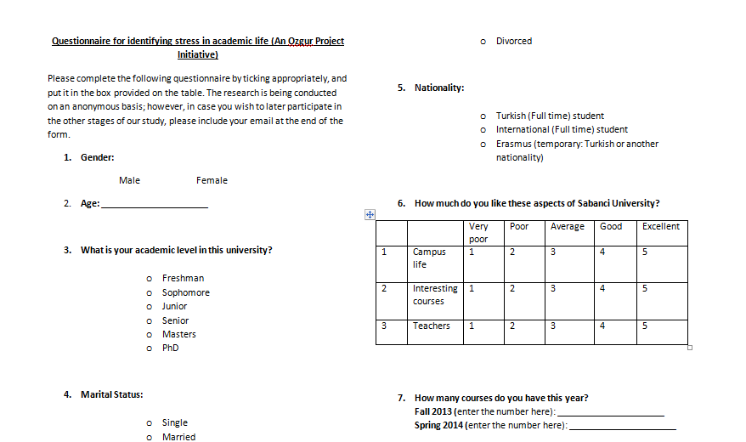

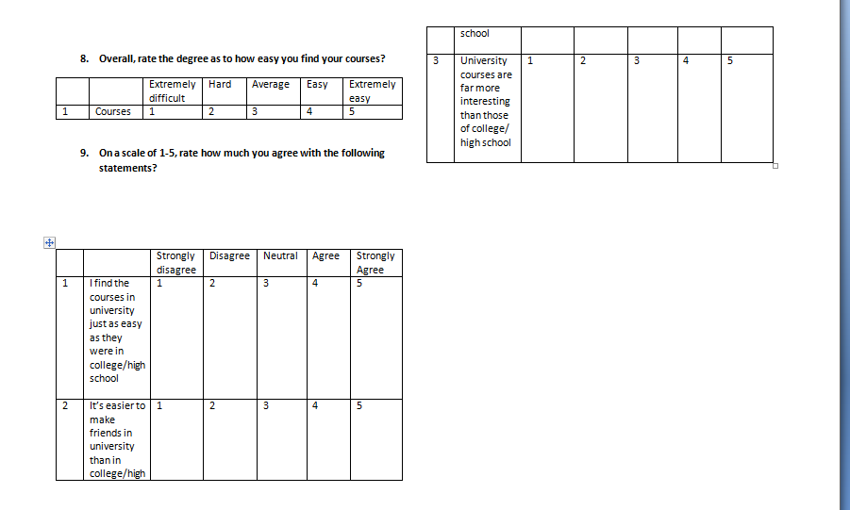
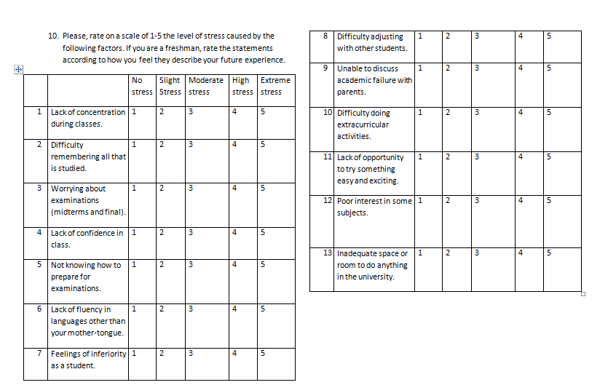
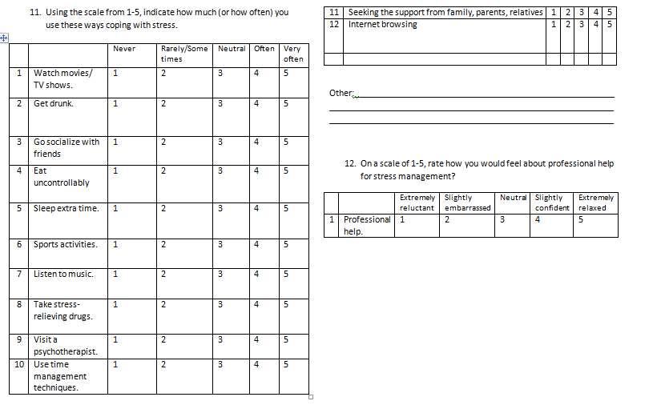

Appendix C
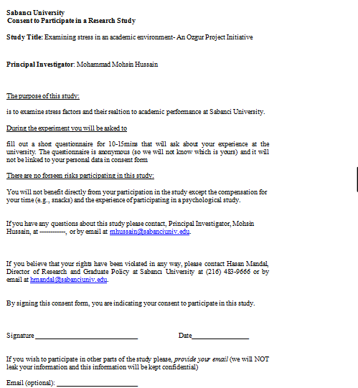

Acknowledgements: Special thanks to Ms Olesya Blazenkhowa for helping us design both the questionnaire as well as fill out details for the consent form in order to ensure it got accepted by the Ethical Committee of Sabanci University;
Special thanks to Sir Mehmet Bac, who both supervised as well as provided guidance and resources when they were need by us. We could not have pulled this project without his help.

References
Misra, R., & McKean, M. (2000). College Students’ Academic Stress and its Relation to Their Anxiety, Time Management, And Leisure Satisfaction. Washington DC: American Psychological Association.
Macan, T. H., & Shahani, C., & Robert, L. D., & Philips, A. P. (1990). College Student’s Time Management: Correlations with Academic Performance and Stress. Washington DC: American Psychological Association.
Case study - Psychology and Anxiety/Stress―SCIPS. N.p., n.d Web. 21 Apr.2013
The Globe and Mail. The Globe and Mail. N.p.,n.d. Web. 21 Apr. 2013
Student Stress at University and College Reaching All-time High | Windsor Star." Windsor Star. N.p., n.d. Web. 21 Apr. 2013.
Beswick, Katie. "Academia, Stressful? Not for Me!" The Guardian. Guardian News and Media, 08 May 0018. Web. 21 Apr. 2013.

