ÖZGÜR PROJE – Yiğit ÖZKAN & Pınar YİRMİDOKUZ

Topic:
Missing my first year’s Özgür Proje application, I was determined to apply for it this year. However, in the beginning, I was having trouble to find a satisfying question which a project can be done on. I wanted something about music, but cannot specify this huge topic, “music”. Then, I started to think about the question which arouses my interest since my childhood; “Does making babies listen classical really help their mental development by relaxing them?” Thus, I started to bend on this question. Meanwhile, I was taking my friend’s, who is studying psychology major in another university, advices about this idea. After few discussions we came up with the question; “How music and human beings are related?”
Then we derived this question and instead of searching for the emotions, we became more curious about the reactions of the human body, while an individual is listening music. We were thinking, what the reason might be behind the differences of the human’s reactions to music; when some people start to dance even with a small musical sound, and some might totally ignore the audio tracks which attract most of the people. Thus, we ended up with our main question, and decided to run our project basing on this question; “How people from different cultures feel music in their bodies?” In a while, the project I started alone became a project of two, because my friend, whose name is Pınar, was standing by me and helped me a lot to derive and develop the basics of my project. Thus, we started to do work sharing to accomplish the application for the project until its deadline and kept working together until then.
Our question was mostly done; but as well as, differences in individuals’ perception of music, we also would like to compare the cultures of the individuals, and see if there exists any differences in the reactions of their bodies of the individuals coming from different cultures.
Moreover, there are so many experiments based on the relation, interaction between the music and the human beings. Although the experiments are not proved totally, it is seen that people are motivated and well-affected when they are exposed to music (Jurado, 2010). However, is it the case for always? Would someone react same/similar when s/he listen heavy metal and classical music?
Execution Plan:

From 4 different cultures (e.g., Turkish, Pakistani, English, Austrian) will participate in the study; 50 from each culture. They will be asked to fill out the surveys and perform music task.
Survey will include questions about:
- Music questions (how often they listen music, what kinds of music do they prefer, music preference history, any musical training professional or amateur, level of exposure of their own culture ethnic music) to measure their music background
- Cultural questions (ethnic background, how long lived in the country, birthplace, birthplace of the parents, native language, sense of cultural belongness) to measure their cultural identity
- Question about the body (experience with sports, dance, yoga etc.) to measure the level of awareness of their body
Music task
- Participant will listen different kinds of music (classic, heavy metal, soft rock, abstract music, ethnic music of their own and other cultures)
- Each music fragment will be relatively ~30 seconds
- They have to shade inside the body outlines the specific body parts that they experience feelings in
- If they don’t have any feeling in the body (meaning that, the music they are listening does not trigger any of his/her body part), then they will have a choice to draw inside a box, which will be located

Analyzes
- For the analysis, the bodily maps will be averaged across participants deepening on their culture and music type (see the example of such averaging below, from the paper called “Bodily maps of emotions”)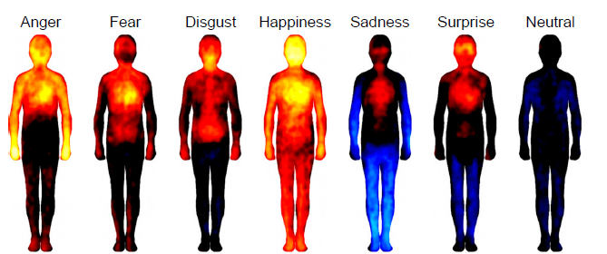

References:
- Nummenmaa, L., Glereana, E., Harib, R., & Hietanend, . K. (). Bodily Maps of Emotions.PNAS, , 6.
- Jurado, A. (2010). 7 Insane Ways Music Affects The Body (According to Science). Cracked.com. Retrieved April 25, 2014, from http://www.cracked.com/article_18405_7-insane-ways-music-affects-body-according-to-science.html
- Storr, A. (1992). Music and the mind. Free Press.
- Bootby, S. (2013). How Music Affects Our Moods. Healthlines RSS News. Retrieved April 25, 2014, from
http://www.healthline.com/health-news/mental-listening-to-music-lifts-or-reinforces-mood-051713
- Sherman, M. (n.d.). How does music affect people?. How Does Music Affect People?. Retrieved April 25, 2014, from http://www.catalogs.com/info/books-music-dvd/how-does-music-affect-people.html

