OLSP DIGEST No: 22

Name of the tool | Mentimeter
URL | https://www.mentimeter.com/
What is it? | Mentimeter is a simple and powerful interaction tool.  It is a cloud based tool that lets you engage and interact with your audience in real time.  You set your questions and your audience can give their answers via mobile phone or any other internet connected device.
How to? | You can watch this introduction video on Vimeo on how it works .https://vimeo.com/112264046  Step 1:  You sign up with your name, e-mail and password. Create an event and prepare your questions. You can also use previously prepared sample questions.  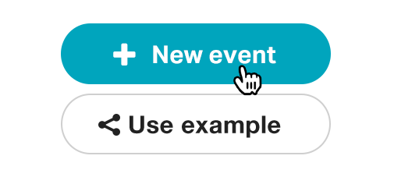  Step 2: Your audience goes to the website, enters a code for your presentation and votes. No installation or setup needed.  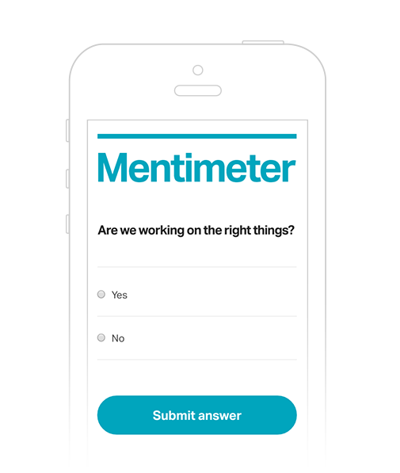  Step 3: As soon as the votes drop in, the results will be displayed in real time. You always have the option of hiding the results until you receive all the answers.  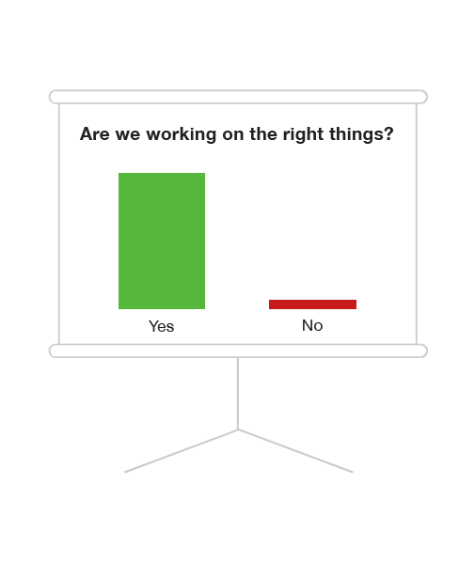
Links, articles, resources, sample URLs  Classroom uses- sample URLs  Limitations | Positive features  - It provides immediate response from your audience.  - It can be used at education, conferences, meetings, events, research projects, workshops for different purposes.  - There are no downloads. You don’t have to install anything.  - All you need is the mentimeter website, and your audience can easily use their smart phones, tablets or laptops to vote.  - The user interface is straightforward. It is easy to set up your questions. Register for a Mentimeter account and get started. Your audience do not need accounts.  - There is a variety of question types including multiple choice, word cloud, open-ended, scales and points allocation.  - There is plug in for those using PowerPoint on a PC. This requires Office 365 login.  - No limitations on the number of voters.  - You can create infinite number of presentations.  - You can share your result of your presentation via social media by sharing the URL.  Negative features  - There is a limitation for free version. You can only ask 2 questions per event. In order to create more questions, you are supposed to upgrade your account.  - You can’t download the results of your polls for later analysis and you can’t track who responded.  - Mentimeter responses are only choices. Participants cannot fill in blanks, so it is not very suitable if you are looking more than a yes, no or multiple choice answer.  - You can’t save surveys.  Classroom integration ideas  - As an ice-breaker (Open the class with a question to spark a discussion relevant to what you will be discussing in class.  - As an energizer  - As a warm up activity  - As a formative assessment tool  It can be used as a formative assessment tool. It helps the teacher understand if the class has grasped the concept and if you can move on.  - As a brainstorming activity  It works well as brainstorming activity, leads to class discussion  - As a pre- assessment tool  You can post a question to the class to gain existing background knowledge.  - To integrate Ss into the lesson  - Exit Ticket: Ask an open ended question to see what students learned that day in class.  - Check for understanding: Ask open ended or multiple choice questions that align with material just covered in class to see if students are understanding the concepts.  - Student Choice: Allow students to choose the next novel or vote on which type of project they would like to complete.  - One Word Splash: Students submit a one-word summary of the day's lesson. When setting up the question, choose to have results displayed as a word cloud. The words that are submitted the most will appear the largest.  - Gauge student understanding: Ask a scaled question to see how confident your students are feeling in understanding the material being covered in class.  How to use it at workshops  - To manage expectations in a fun way (To know the expectations of the group before a workshop. You can begin the workshop by posting a simple free text question using Mentimeter.)  - To understand and discuss the strong features of the tool introduced at the workshop  How to use it for meetings  - To quick vote on decisions  - Do a quick analysis of what you and your team should focus on.
 | For further information, please refer to the following links
media.leidenuniv.nl/legacy/mentimeter-handleiding-fgw.pdf
https://prezi.com/hxtyztmuqlzd/mentimeter/

