OLSP DIGEST No:1

Name of the tool | Studystack
URL | https://www.studystack.com
What is it? | Studystack is a web site which helps students to memorize vocabulary by having fun.  It provides millions of sets of flashcards which already exist in the site. Categories of flashcards vary.  Students/Teacher can also create their own flashcards. Once they create their own set of cards, for each set of cards, the site automatically creates several other activities including crosswords, hangman, matching and scrambled words.
How to? | - You can watch this introduction video on the link below to have a general idea on how it works .  https://www.youtube.com/watch?v=geOJmK-7zgU  - You can either use the flashcards which exist in the site by searching for topic or create your own set of flashcards. In order to create your own set of cars, please follow the steps below:  Step 1: First, you need to sign up for a free account with a username and password.  Step 2: Click on Create a new stack and  describe the flashcards you are going to create on the settings tab.  Each row corresponds to 1 flashcard. If you need you can add more blank rows by clicking onto add blank rows.  Step 3: Save the data necessary on the data tab.  Step 4: After you save, you can immediately use all the activities to study. Once you have created and saved your set of flashcards, the site will automatically create the following activities for you to study.  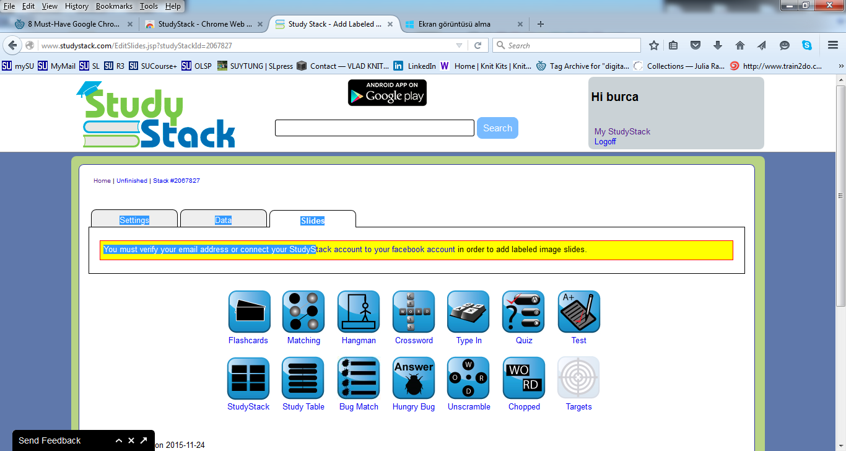
Links, articles, resources, sample URLs  Classroom uses- sample URLs | For any further questions, please visit the following link  http://www.studystack.com/FAQ  I have tried it in my class. I have divided sts into pairs and assigned them different set of  words from their TLPs. Each pair signed up for a free account and prepared their own set  of flashcards.  After doing the activities related, they tried each others stacks.  http://www.studystack.com/wordscramble-2068707  http://www.studystack.com/flashcard-2068715  How can I share my stacks with others?  You can share your public profile page which is at http://www.studystack.com/users/bcapkan to allow others to easily view the stacks that you created and the ones that you have marked as a favorite. (You can change the user name for your account by going to your "My StudyStack" page and clicking on the Account tab.)

